Contents

3.1 Analysis of the problem 3
3.1.1 Problem identification 3
3.1.2 Stakeholders 4
3.1.3 Research the problem 5
3.1.4 Specify the proposed solution 13
3.2 Design of the solution 15
3.2.1 Decompose the problem 15
3.2.2 Describe the solution 17
3.3.3 Describe the approach to testing 29
3.3 Developing the solution 32
Milestone 1a: Part 1 - Development of the Login/ Registration module 32
Milestone 1a: Part 2 – Testing 36
Milestone 1a: Part 3 – Stakeholder feedback 39
Milestone 1a: Part 4 – Review 40
Milestone 1b: Part 1 – Refinement of the Login/ Registration module 41
Milestone 1b: Part 2 – Testing 43
Milestone 1b: Part 3 – Stakeholder feedback 45
Milestone 1b: Part 4 – Review 46
Milestone 2: Part 1 – Development of the Physics Engine 47
Milestone 2: Part 2 – Testing 50
Milestone 2: Part 3 – Stakeholder feedback 51
Milestone 2: Part 4 – Review 52
Milestone 3a: Part 1 – Development of Game Animation & Refinement of Physics Engine 53
Milestone 3a: Part 2 – Testing 59
Milestone 3a: Part 3 – Stakeholder feedback 62
Milestone 3a: Part 4 – Review 63
Milestone 3b: Part 1 – Refinement of Game Animation 64
Milestone 3b: Part 2 – Testing 65
Milestone 3b: Part 3 – Stakeholder feedback 66
Milestone 3b: Part 4 – Review 67
Milestone 4: Part 1 – Development of Collision Detection 68
Milestone 4: Part 2 – Testing 69
Milestone 4: Part 3 – Stakeholder feedback 70
Milestone 4: Part 4 – Review 71
Milestone 5: Part 1 – Development of saving user progress 72
Milestone 5: Part 2 – Testing 73
Milestone 5: Part 3 – Stakeholder feedback 75
Milestone 5: Part 4 – Review 76
Milestone 6: Part 1 – Development of settings, music & instructions 77
Milestone 6: Part 2 – Testing 79
Milestone 6: Part 3 – Stakeholder feedback 81
Milestone 6: Part 4 – Review 82
3.4 Evaluation 83
3.4.1 Testing to inform evaluation 83
3.4.2 Success of the solution 86
3.4.3 Describe the final product 88
3.4.4 Maintenance and Development 89

3.1 Analysis of the problem

3.1.1 Problem identification

The problem:
Sixth form students work hard throughout the year in order to achieve good grades in their A levels. Many of them like to play videogames to relax. However, these videogames are seldom beneficial to their education. It would be better to have games that are linked to the subjects studied at school as this could lead to improved academic performance.
Many students in my year 12 Physics class struggled with kinematics, especially projectile motion. Therefore, I will create a game which involves users firing projectiles at objects. The game will require mathematical and scientific knowledge as users will need to calculate the path the projectile needs to take. For example, they may need to consider variables such as air resistance and gravity as these may change the motion of the projectile. The game will have many levels are get progressively harder as the difficulty of the calculations required increases.

Why the problem is amenable to a computational approach:
This problem is amenable to a computational approach for two main reasons. The first reason is because the solution will use algorithms to calculate the projectile path whilst taking in user outputs. The second reason is because the solution will output the motion of the projectile onto the screen using animations and graphics.

Why the problem is solvable by computational methods:
There are several computational methods that can be used to solve this problem.
Problem recognition:
The overall problem is being able to accurately animate the path that a projectile will take. The underlying problem is calculating the path that the projectile will take by taking into account the variables that may affect its motion. When the underlying problem is overcome, the rest of the solution is simply applying the information relating the motion of the projectile to the animation so that the user can see what happens.

Problem decomposition:
This problem can be decomposed into smaller steps.
For each level in the game:
- Set up projectile and target at certain distances and angles away from each other.
- Set up the variables such as terrain, air resistance, gravity.
- Allow the user to input the speed and angle of release of the projectile
- Use mathematical calculations to work out the motion of the projectile and see if it hits the target.
- Animate this, making sure to account for the scale of the screen and other potential computer configurations.

Use of divide and conquer:
The overall problem can be divided into these smaller steps. Each of these steps can then be conquered individually and combined together to make the final program. Using this method means that the complex overall problem is split into more manageable smaller problems which makes development easier.

3.1.2 Stakeholders

My solution will be of interest to two different groups of people.
The first group is comprised of those that study Physics or Mathematics at A level and struggle with the topic of projectile motion. For them, my solution will be of academic interest as it could help improve their understanding of the topic. They would be most interested in the mathematical and scientific calculations behind the projectile motion.
The second group is comprised of those that have an interest in videogames but also want to be intellectually challenged by the game. For them, my solution will be for personal enjoyment. They would be most interested in the playability and the graphics of my solution.
My main stakeholder will be David Kuc. He studies Mathematics and Physics at A level so my solution will benefit him by allowing him to recap projectile motion. He also enjoys playing computer games, so the solution will benefit him through increasing his personal enjoyment.
Therefore, he will be able to represent to two main groups of people who would have an interest in my solution.

3.1.3 Research the problem

Existing similar solution 1 – ‘Angry Birds 2’:
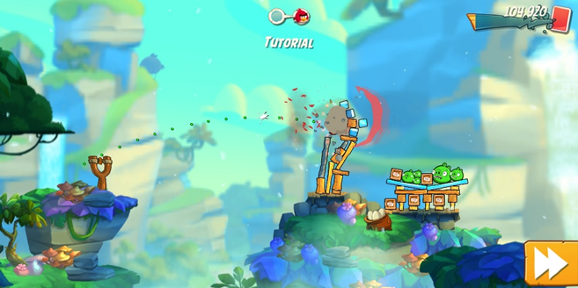

‘Angry Birds 2’ is a game where players use a slingshot to launch birds at nearby targets. The game can be played on multiple platforms but I tested the game on a mobile phone. The slingshot is directed using hand movement on the screen. The game shows the path that the bird will take using green dots. The game has music in the background. There are multiple levels and the difficulty increases as you progress.
There are many features of the game that I like and could possibly apply to my solution:
- Shows the user the path that the bird will take.
- Graphics are detailed and in 3d.
- The slingshot is easy to control and adjust using hand movement.
- There are rewards for hitting targets.

Existing similar solution 2 – ‘PhET Projectile Motion’:
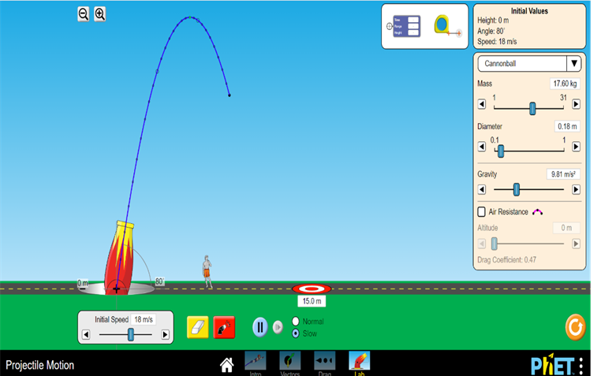
‘PhET Projectile Motion’ is a simulator where you can fire projectiles. It is not a game but is instead used for educational purposes.
There are several features of the simulator that I like and can apply to my solution:
- Shows the path that the projectile takes using a series of blue dots connected together with a blue line.
- Angle that the projectile is fired at is easily adjustable through mouse movement.
- Speed of the projectile is easily changed through a slider bar.
- Can change the speed of the animation.

Existing similar solution 3 – ‘Galileo and Einstein Projectile Motion’:

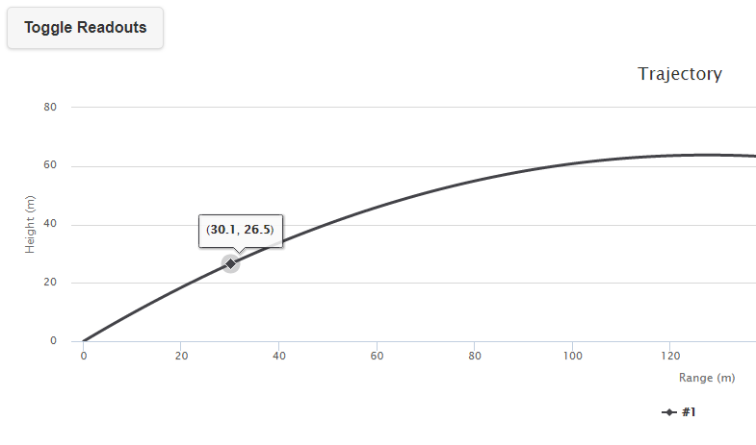
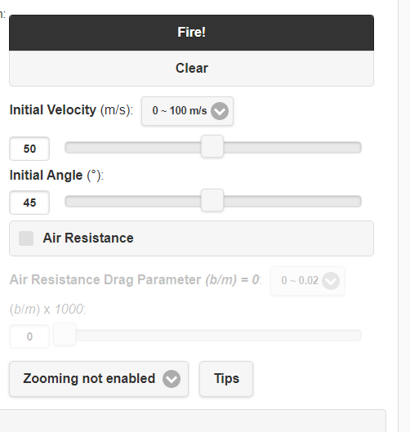

‘Galileo and Einstein Projectile Motion’ is a simulator where you can plot the paths of projectiles . It is not a game but is instead used for educational purposes.
There are several features of the simulator that I like and can apply to my solution:
- Shows the path that the projectile takes using a series of blue dots connected together with a blue line.
- Angle that the projectile is fired at is easily adjustable through mouse movement.
- Speed of the projectile is easily changed through a slider bar.
- Can change the speed of the animation.

Survey:
I conducted of stakeholders. I decided to ask the following questions to find out he general features that my users wanted from my solution and their experience of any similar solutions.
1. How big should the game screen be?
2. How would you like to fire the projectile?
3. Do you want the game to save your progress?
4. What would be your preferred method of playing the game?
5. What features would you like the game to contain?
6. If you have ever played a similar game, what features did you like?
7. Would you like music in the game and if so, what type?
8. Any other comments

Q1: How big should the game screen be?
- Full screen [42.86%]
- Window [57.14%]
Analysis: The majority of stakeholders prefer a window.

Q2: How would you like to fire the projectile?
- Entering values manually [42.86%]
- Slider bar [57.14%]
Analysis: The majority of stakeholders prefer a slider bar system.

Q3: Do you want the game to save your progress?
- Yes [85.71%]
- No [14.29%]
Analysis: Overwhelming consensus is for the game to save user progress.

Q4: What would be your preferred method of playing the game?
- Computer/ Laptop [85.71%]
- Mobile phone [14.29%]
- Other [0%]
Analysis: Overwhelming consensus is for the game to be computer/ laptop based.

Q5: What features would you like the game to contain?
- It should be fun, not too ugly and not boring or too challenging. It should have different levels or difficulties.
- Some kind of goal - i.e. a reason to play the game. Maybe make an adventure mode or something with different levels of difficulty as you progress.
- Choice of colour for the projectile
- Good graphics.
- Projectile skins.
- Easy controls.
Analysis: Wide range of opinions received. Most stakeholders want some kind of customisability.

Q6: If you have ever played a similar game, what features did you like?
- Angry birds: it had intuitive controls and was fun.
- The game would report back on how close/far I was.
- Angry birds had fun physics and structures to destroy. Was pretty satisfying.
- The sound when the object hits the target or misses it.
- Chain reactions objects, like hit an explosive barrel to cause a greater effect.
- Being able to aim easily.
Analysis: Wide range of opinions received. Some stakeholders played ‘Angry Birds’ which I had already analysed as an existing solution. Other interesting features were mentioned.

Q7: Would you like music in the game and if so, what type?
- Yes. Ambient or relaxing music. It can be fast paced energetic music if it suits the game, but it shouldn't be too distracting. There should always be an in-game option to turn music and sound effects off.
- Yes. Any kind is fine. If it's not too complex, making the option to switch between different tracks might be nice.
- Yes. Instrumental music.
- Yes. Happy uplifting stuff.
- Yes. Upbeat music.
- Yes. Chiptune could be cool
- Yes. Non distracting.
Analysis: All stakeholders would like music. However, there is no consensus on the type.

Interview with main stakeholder:
Once I had the results of the survey, I decided to conduct an interview with my main stakeholder. I asked him (David Kuc) the same questions but was looking to gain more detailed and specific answers, especially where the opinions from my survey had been more unclear.

Q1: How big should the game screen be?
I would like it to be a window. There are a few reasons why.
Primarily, by using a screen, the user can easily switch between the game and other applications at will without the hassle of the processor having to refocus other tasks.
Also, a screen can be resized to the desirable size and resolution by the user.
Overall, a screen is more beneficial for using other applications simultaneously which is why I prefer it.
The only downside to a screen is that the CPU and GPU are also being used by other processes so you may experience lag or limited FPS. Though given that this game is unlikely to use excessive amounts of processing power, it isn't much of an issue.
Analysis: The main stakeholder has a clear preference for a window.

Q2: How would you like to fire the projectile?
A slider bar system would be preferable. This is because it allows the user to adjust the values without having to type them in.
This decreases the accuracy of the number selection; however, it is a lot easier to slide a bar than manually type out a value.
For this game, it is unlikely that the user will need to be too specific about their values, which is why I'd recommend focusing on usability over accuracy.
Analysis: The main stakeholder has a clear preference for a slider bar system.

Q3: Do you want the game to save your progress?
Yes, definitely.
Analysis: The main stakeholder would like the game to save user progress.

Q4: What would be your preferred method of playing the game?
I would like to play the game on my laptop.
Analysis: The main stakeholder would like the game to be computer/laptop based.

Q5: What features would you like the game to contain?
I think that generally, users like customisability. You shouldn’t restrict the users by using set systems for everything, but instead try to allow for options and variety wherever possible.
The more that a user can customise the game; the more likely they are to do so. And if a person spends a long time setting something up, they are unlikely to give up all of that effort easily, so it’s another way of drawing people in and having them keep playing.
Analysis: This answer is particularly helpful. It shows that I should give the users as much flexibility and control as possible.

Q6: If you have ever played a similar game, what features did you like?
I have played Wii bowling and Angry Birds. However, I have played a variety of other games where you need to complete similar objectives as side tasks or minigames.
I liked having to avoid obstacles, and having other external elements act on the system like wind and gravity.
Analysis: This answer gives me some ideas of the successful features of similar games.

Q7: Would you like music in the game and if so, what type?
Yes, but the music should depend on the theme of the game. For example, if the setting is in space, then the audio should complement that setting.
I’d recommend creating a variety of themes, which can either be toggled by the player, appear randomly, or occur for certain predetermined levels, where the background, sprites and music all change and are all linked together.
For example, if there is a nature theme where the background is a forest, the sprites should be natural colours and the music should be like something from ‘The Hobbit’.
Analysis: The main stakeholder would like the music to represent the ‘mood’ of the game.

Essential features of the computational solution:
From conducting the survey and the interview, I was able to find out what the essential features of my solution will be.
Feature | Justification
Game screen will be windowed | Most stakeholders would prefer a windowed screen compared to a full screen.
Projectile will be fired using a slider bar | Most stakeholders would prefer a slider bar system compared to a manual entry system.
Game will save user progress | Most stakeholders would prefer the game to save their progress.
Users will be able to register / login | This is necessary in order for the game to save user progress.
Game will be playable on a computer / laptop | Most stakeholders would prefer the game to be playable on a computer / laptop.
Game will have several levels which increase in complexity | This provides a purpose to the game.
Users will be able to toggle music between on and off | This allows the user to have more control over the game.

Limitations of the solution:
The main limitation of my solution will be the precision of the projection motion calculation. This is because the calculation will involve imprecise values. For example, a slider bar system will limit the precision to which the user can specify the speed of the projectile. This will mean that the calculations carried out by the program may result in values that are slightly different to what the user intended.
To fix this limitation, I will include a margin of error in all calculations meaning that slight variations in values will be accepted. This will make it easier to users to hit the target with their projectile.

3.1.4 Specify the proposed solution
The solution requirements were agreed with my main stakeholder, David Kuc.
Hardware and software requirements:
Requirement | Justification | Type
Windows/Linux/UNIX/Mac OS X Operating System | These operating systems are supported by Python. | Software
Python with Tkinter & Pygame | Needed to run the program. | Software
Computer with keyboard, mouse and monitor | Needed to use the program. | Hardware

Design requirements:
Requirement | Explanation | Justification
Game will be windowed. | Allow users to have other programs open whilst playing the game. | This was a key stakeholder requirement.
User instructions | Shows the users how to play the game and use the software. | This will improve the user experience.
Lightweight design | The game design should be simple and easy to follow. | This will improve the user experience.

Functionality requirements:
Requirement | Explanation | Justification
Projectile fired using a slider bar system. | Allows users to adjust the flight of the projectile. | This was a key stakeholder requirement.
Game progress saved | Allows users to come back to the level they have got to. | This was a key stakeholder requirement.
Login/ registration system – linked to a database | Allows users to create their own account which is linked to their game progress. | This will allow game progress to be saved.
Settings menu | Allows users to adjust settings e.g. music | No general stakeholder consensus on the type of music so will give users options to toggle music on or off.
Unique game levels | Each game level is different as the settings and variables that need to be taken into account will change. | Requested by a stakeholder. Gives a purpose to the game.

Success criteria:
The following success criteria was generated through the survey and interview with my main stakeholder.
Criteria Number | Criteria | How it will be evidenced
1 | The game will be windowed | Screenshot of the window
2 | User instructions will be provided | Screenshot of the game window
3 | The game design will be lightweight | Screenshot of the game window
4 | Use of slider bar system to fire projectile | Screenshot of the game window
5 | Progress of user in the game is saved | Screenshot of the game window + coding + testing
6 | A login/ registration system for users | Screenshot of the game window + coding + testing
7 | User details will be stored in a database | Coding + testing
8 | Settings menu with option to toggle music | Screenshot of the game window
9 | Each game level will be unique e.g. have different values of gravity | Screenshot of the game window + coding
10 | There is collision detection between the projectile and target | Screenshot of the game window + coding + testing

3.2 Design of the solution

3.2.1 Decompose the problem

In this section, I split my solution into smaller parts. By doing this, I make my project easier to program and manage. This is because smaller sections can be completed independently and then combined to create the finalised solution.
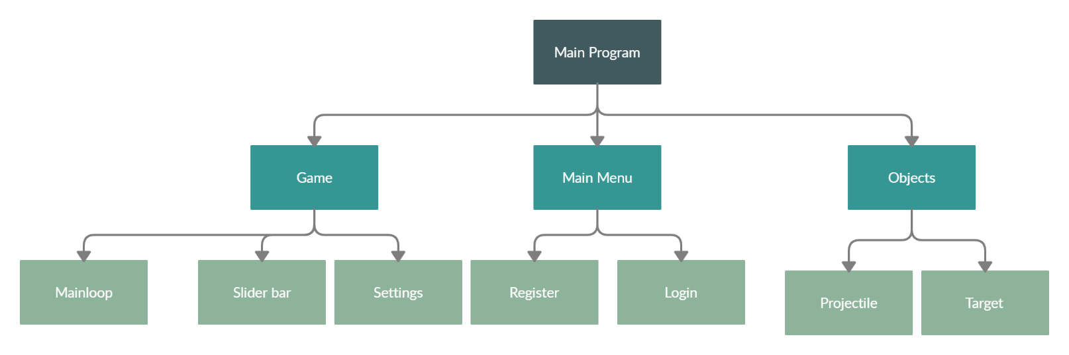

Description of main modules:
Main Menu:
This module will initialise the user interface. It will be a window which will allow the user to choose whether to register or login.

Game:
Initialises the game and game window.

Objects:
Initialises the objects – projectile & target.

Mainloop:
Constantly update the projectile position on the screen and check if there has been any collisions.

Slider bar:
Initialises two slider bars. One for the speed and one for the angle.

Settings:
Button which can be pressed to toggle music or exit the game.

Register:
Window with a username and password field for new users.

Login:
Window with a username and password field for returning users.

Projectile:
Object that will be fired by the user.

Target:
Object that the user will try to hit.

3.2.2 Describe the solution

Structure of the solution:
My solution will be structured modularly. As shown earlier, I will use decomposition to break down the overall solution into smaller and more manageable modules which will be developed indepdently.
There are several advantages to structuring my solution in this way.
Firstly, solving smaller problems will enable faster development as each individual module can be programmed and then all of the modules can be brought together to make the final solution. For example, I can indepdently develop the module for the slider bar system, and then later add it to the overall solution.
In addition, a modular approach makes testing easier. This is because each module can be tested indepently meaning that any errors can be isolated to each module. For example, if there is an error in my program, I would be able to narrow it down to a specific module e.g. mainloop module, and then solve it without inadvertedly spoiling other parts of the program.
A modular approach will also help the program to be more easily read. This is because there will be clearly defined subroutines meaning the flow of the program is easy to follow.
Overall, the are several advantages to using a modular approach and therefore I will apply this approach to my solution.

Algorithms:
Calculate projectile path: This algorithm will take in account the different variables that affect projectile motion and calculate it’s position at every point in time.
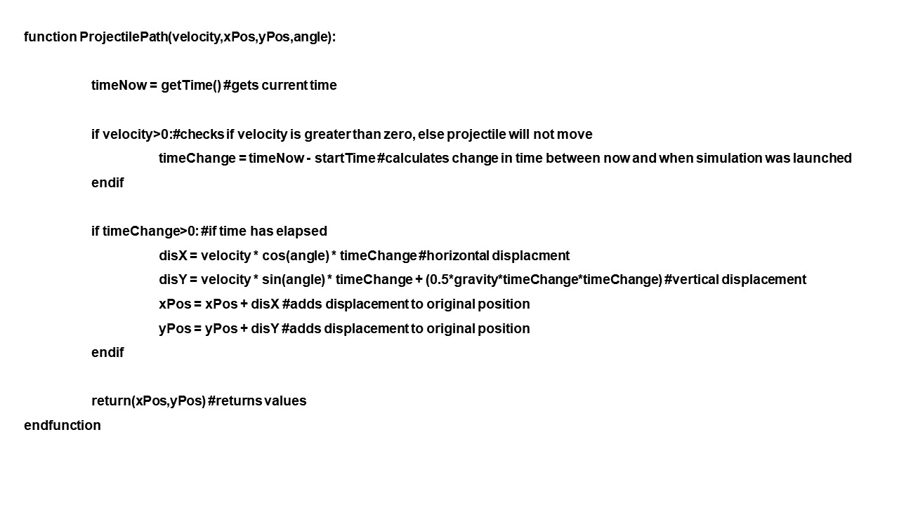
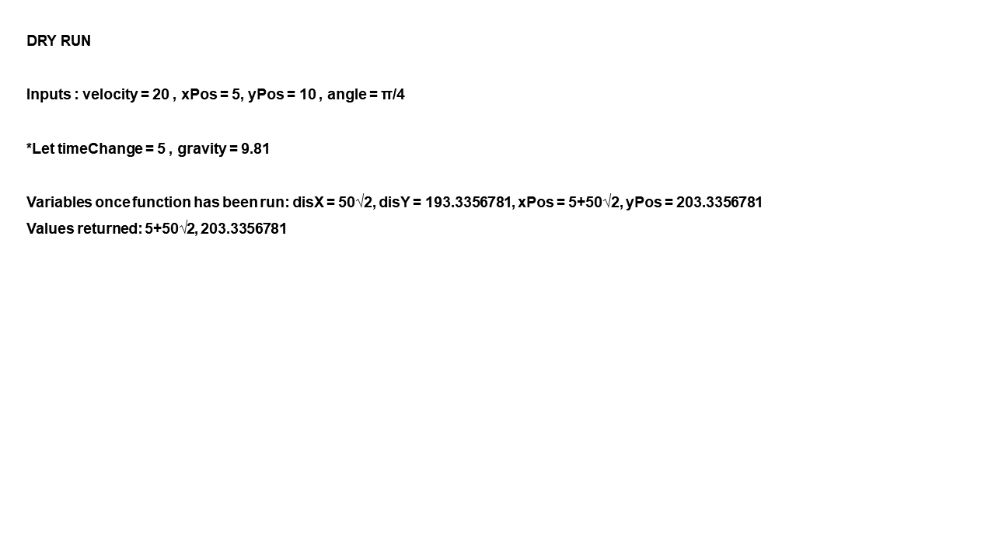

Password (Registering) validation: This algorithm will check if the password the user has chosen meets all necessary criteria.
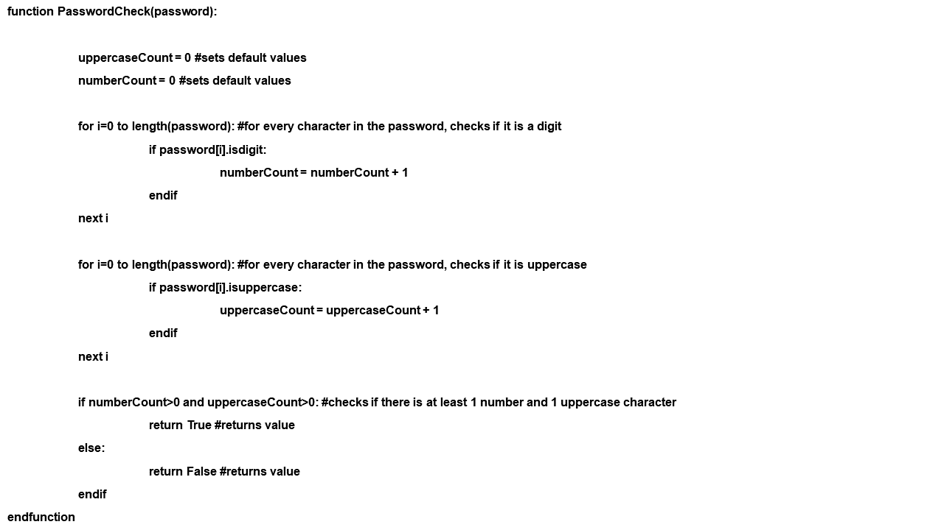

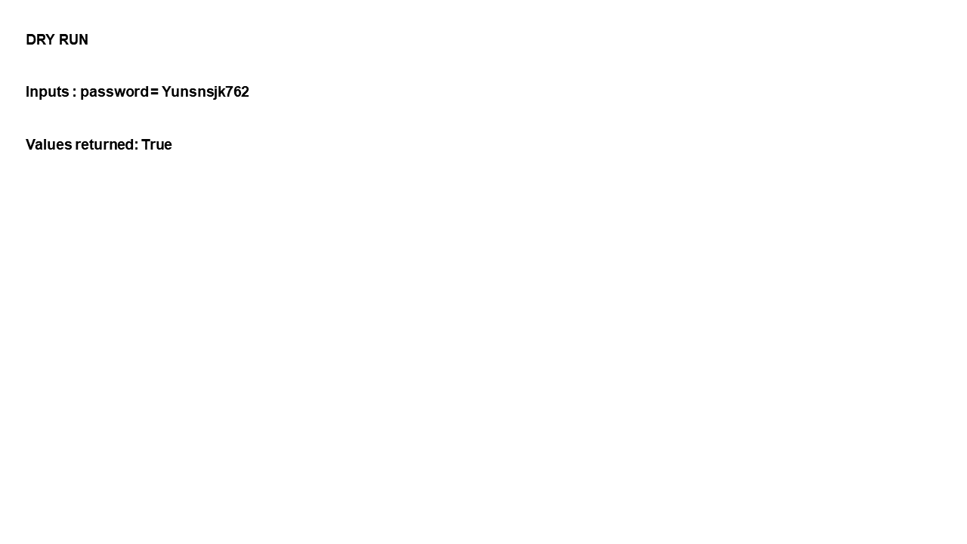

Projectile vs target: This algorithm will check if the projectile has hit the target.
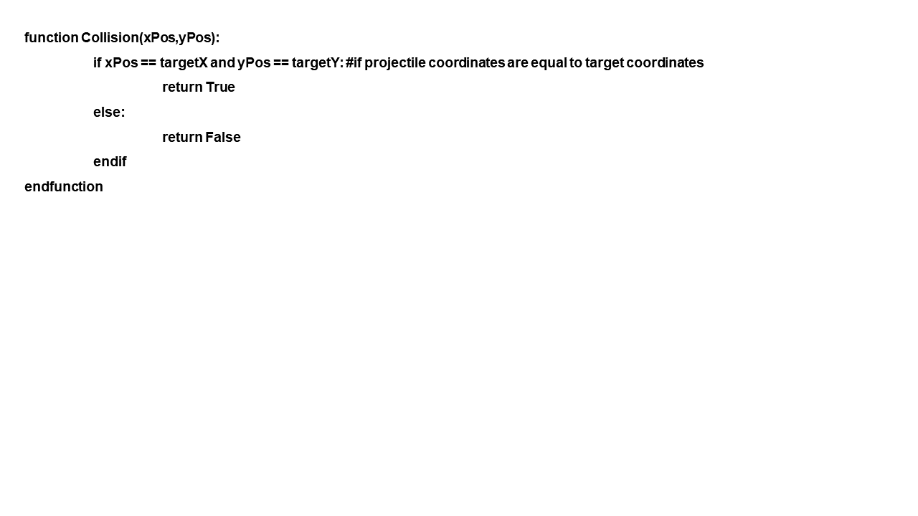
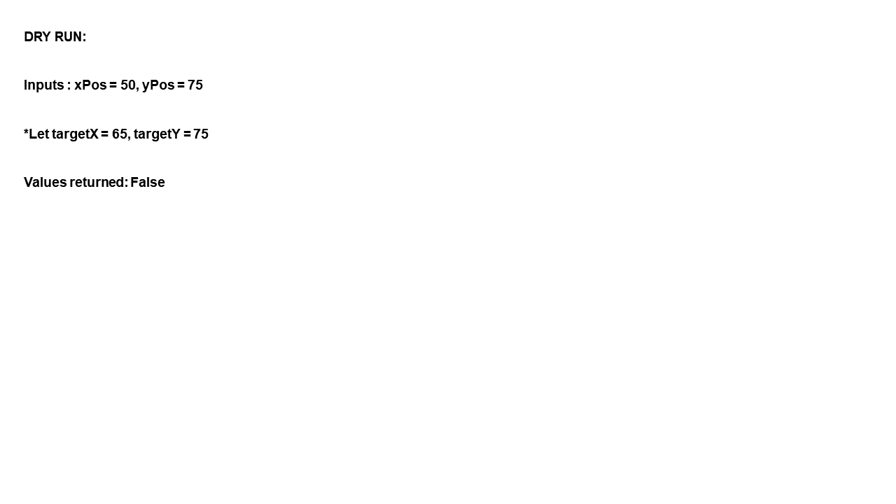

On the screen: This algorithm will check if the projectile is still located within the game window.
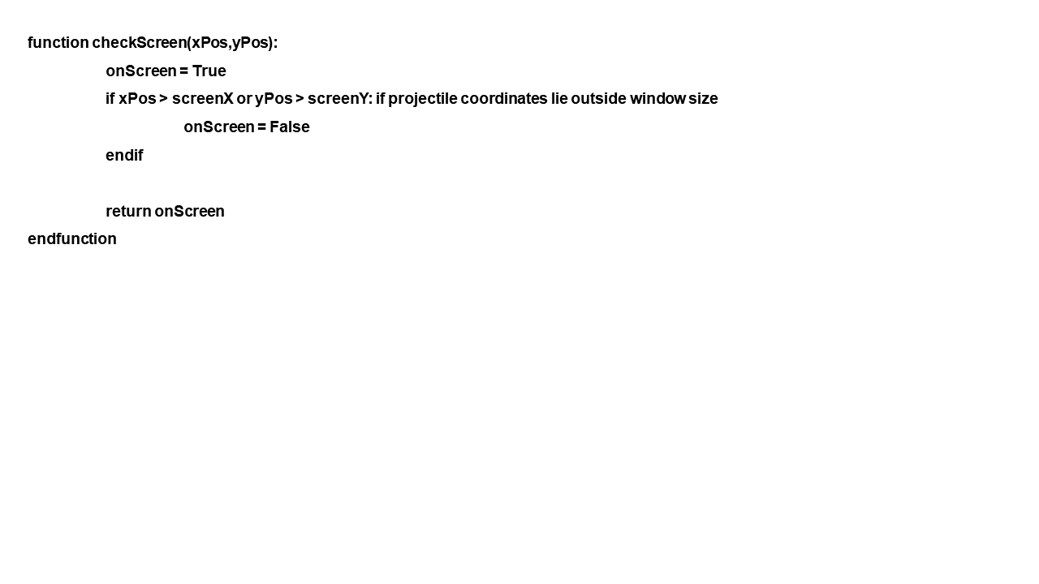
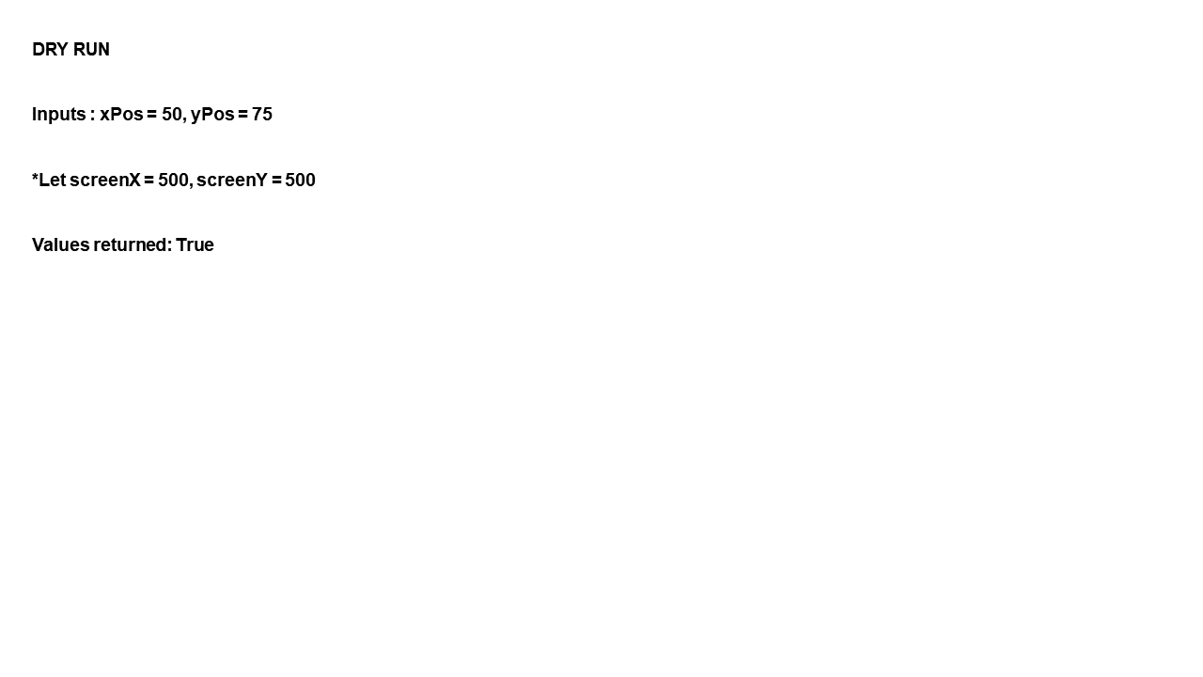

User interface design:
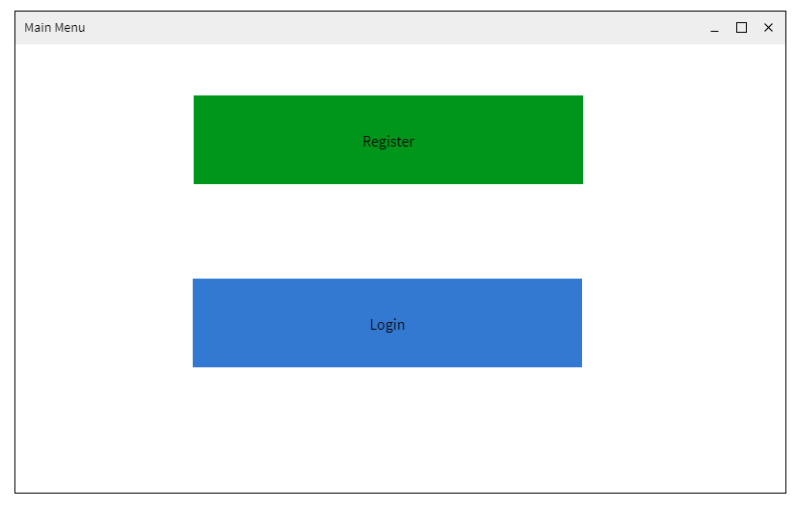This is the first screen that the user will see. It contains two buttons with options to register or to login.
Link to success criteria: A login/ registration system for users
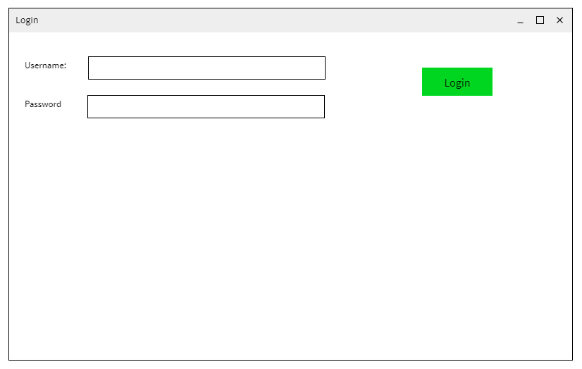
This is the screen that the user will use to login. It contains two fields to enter the username and password.
Link to success criteria: A login screen.
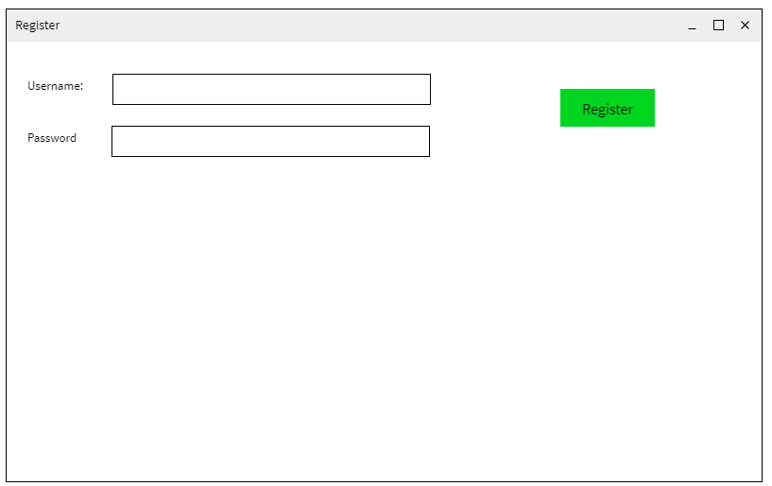
This is the screen that the user will use to register. It contains two fields to enter the username and password.
Link to success criteria: A registration screen.

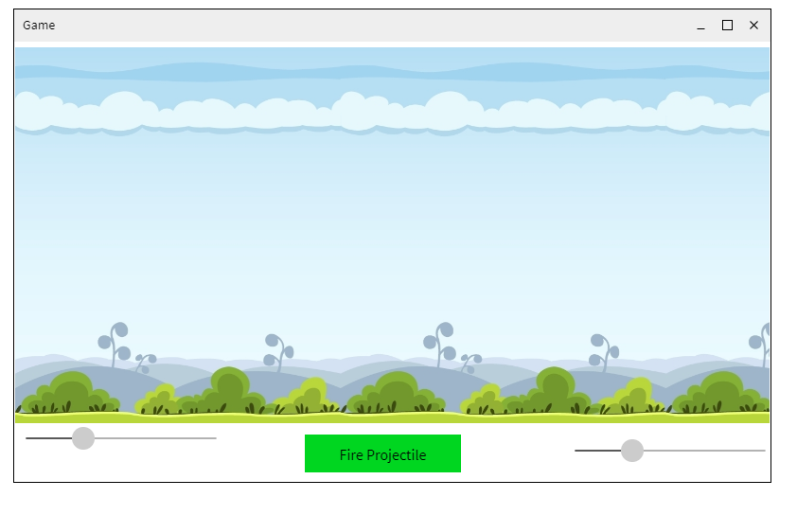
Link to success criteria: Use of slider bar system to fire projectile

Stakeholder feedback:
Make a numeric display to show the angle and initial velocity in detail (so its adjusted by the slider, but displayed clearly with the value).
Given that your login and register screens are so alike, maybe combine them into one, with both buttons available once you have entered in a valid username and password
Perhaps include a background for the login screen
Your sliders should have the same y position

Changes to user interface design (taking into account stakeholder feedback)
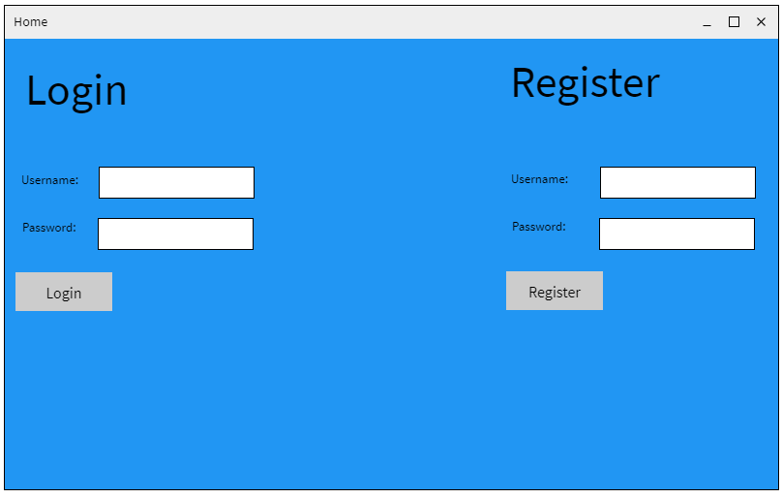
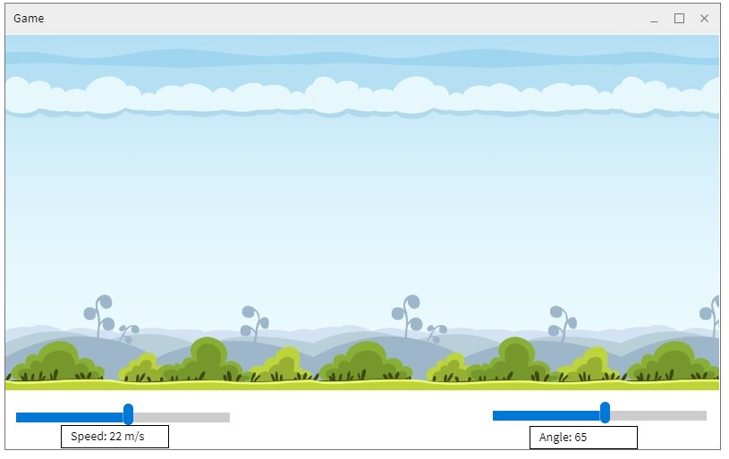
Usability features:
I have considered many usability features so that my program is easy to use.
All of the buttons on my user interface design are large. This is so that people that have difficulty with their vision can see the buttons more easily.
Large buttons
My interface design is very simple with as few buttons and text as possible. This is so that the users can easily understand the information that is presented to them. This lightweight design will improve the user’s experience
Few buttons and text
.

Key Variables:
These are the main variables that my program will use.
Variable Name | Data Type | Description / How it is used | Justification
velocity | Floating Point | To store the velocity that the user has inputted. Will be measured in metres per second. It is used in the calculations of the projectile motion. | Needed for projectile motion calculations.
xPos | Floating Point | To store the horizontal position of the projectile on the screen. It is updated with every tick of the game clock. It is used in the calculations of the projectile motion. | Needed for projectile motion calculations.
yPos | Floating Point | The store the vertical position of the projectile on the screen. It is updated with every tick of the game clock. It is used in the calculations of the projectile motion. | Needed for projectile motion calculations.
angle | Floating Point | The store the angle of the projectile (measured to the positive x-direction; measured in radians). It is used in the calculations of the projectile motion. | Needed for projectile motion calculations.
disX | Floating Point | To store the horizontal displacement of the projectile in each tick of the game clock. It is used in the calculations of the projectile motion. | Needed for projectile motion calculations.
disY | Floating Point | To store the vertical displacement of the projectile in each tick of the game clock. It is used in the calculations of the projectile motion. | Needed for projectile motion calculations.
loginUsername | String | To store the username that the user has inputted (when logging in). | Needed to implement login system
loginPassword | String | To store the password that the user has inputted (when logging in). | Needed to implement login system
registerUsername | String | To store the username that the user has inputted (when registering). | Needed to implement registration system
registerPassword | String | To store the password that the user has inputted (when registering). | Needed to implement registration system
startTime | Floating Point | To store the time of the game clock when the game was launched. | Needed for projectile motion calculations.
timeNow | Floating Point | To store the time of the game clock at a certain point. | Needed for projectile motion calculations.
timeChange | Floating Point | To store the difference between the value of ‘startTime’ and ‘timeNow’. This is then used in the calculations of the projectile motion. | Needed for projectile motion calculations.

Validation:
I will validate all user inputs to make sure that the program is robust. To do this, I will check if the data is of the correct type and size.
Initial velocity:
It must be a floating point value. It cannot be negative and cannot be zero – otherwise the projectile will not move.

Angle of release:
It must be a floating point value. It will be entered in degrees (will be converted into radians during the program. Must be between 0 and 90, measured from the positive x-direction.
Login Password:
It must be at least 8 characters in length and contain at least 1 number and 1 uppercase character.

Example validation algorithm:
function PasswordCheck(password):

uppercaseCount = 0 #sets default values
numberCount = 0 #sets default values

for i=0 to length(password): #for every character in the password, checks if it is a digit
if password[i].isdigit:
numberCount = numberCount + 1
endif
next i

for i=0 to length(password): #for every character in the password, checks if it is uppercase
if password[i].isuppercase:
uppercaseCount = uppercaseCount + 1
endif
next i

if numberCount>0 and uppercaseCount>0: #checks if there is at least 1 number and 1 uppercase character
return True #returns value
else:
return False #returns value
endif
endfunction

Buttons:
The buttons in my program will be part of Tkinter, making them robust. The buttons will not be linked directly to any functions, so there is no risk of passing incorrect data.
Sliders:
The sliders in my program will be part of Tkinter, making them robust. I will ensure that the sliders are set to have minimum and maximum values that are acceptable for the program so will not cause any errors. The sliders will not be directly linked directly to any functions, so there is no risk of passing incorrect data.

3.3.3 Describe the approach to testing

Testing:
In this section I will outline both the iterative development and post development testing.
Testing methods:
Black box: This testing is carried out independently of the code of the program. It will involve testing the inputs and outputs.
White box: This testing checks the the logic of code.
Alpha: This testing is carried out by the software developer’s testing team. As I am the sole developer, I will undertake this testing.
Beta: This testing is carried out by potential users. For this, I will get my main stakeholder, David Kuc, to undertake this testing.

Iterative development:
To complete my program, I will use iterative development. This will mean that I will decompose the problem (as explained earlier) and then solve and test each section independently. This means that after each section is developed and tested, a prototype will be created.
Main Test Plan:
Test Number | Success Criteria Reference | Description | Input(s) | Expected Output(s) | Justification
1 | 4 | User can fire the projectile using the slider bar system | Normal: e.g. velocity = 25 m/s; angle = 60 degrees  Erroneous: e.g. velocity = 0 m/s; angle = 0 degrees | Normal: Projectile is animated to move across the game screen with given velocity at at specified angle of release.  Erroneous: Displays a pop up screen saying that invalid parameter for speed has been entered.
2 | 4 | Projectile motion is calculated correctly | Normal: e.g. velocity = 25 m/s; angle = 60 degrees, time = 2  Erroneous: e.g. velocity = 0 m/s; angle = 0 degrees | Normal: Displacment-x = 25cos15 * 2 = 25.0; displacement-y = 25sin15* 2 - 0.5 * g * 2 * 2 = 23.69  Erroneous: Error message saying that the projectile motion cannot be calculated.
3 | 5 | User’s progress is saved by the game | N/A | When user loads up the game after closing it, they are taken to the right game level.
4 | 6 | User can sign up | Normal: e.g. username = mark; password = Jhnd3728df  Erroneous: e.g. username = mark ; password = “” | Normal: Displays a pop up screen saying that registration is complete.  Erroneous:  Displays a pop up screen saying that the password has not be the specified criteria.
5 | 6 | User can login | Normal: e.g. username = mark; password = Jhnd3728df  Erroneous: e.g. username = mark ; password = aa | Normal: Displays a pop up screen saying that the login details are correct.  Erroneous:  Displays a pop up screen saying that login details are incorrect.
6 | 8 | Settings button loads the correct screen | Press settings button | Settings screen is shown.
7 | 8 | User can toggle music | Press music button | Music is turned on/ off accordingly
8 | 1 | Game is windowed | N/A | Window containing the game
9 | 2 | Users instructions provided | Press instructions button | Instructions given if users requests
10 | 10 | Collisions are detected between the projectile and target | Projectile velocity & angle; Target position | User is told that they have hit the target and completed the level.

Post development:
In the post development testing I will use: integration testing, alpha testing and beta testing to ensure that the complete solution is tested for function, robustness and usability.
To do this, I will use the same test criteria as used for the itertative development testing.

3.3 Developing the solution

Milestone 1a: Part 1 - Development of the Login/ Registration module

In this milestone, I will develop and test the part of my system which will allow users to register or login to their accounts. This will involve creating a user interface which allows them to do so. Additionally, the interface will be linked to a database, which will store user information.
I first developed the home screen which is what users will first see. It contains the login and register entry spaces.
#main menu screen
def home():
#window setup
window = Tk()
window.title("Home")
window.minsize(800,500)
window.configure(bg="#0394fc")

#top of the screen labels

loginLabel = Label(window,bg="#0394fc",text="Login",font=("",30)).place(x=20,y=20)
registerLabel = Label(window,bg="#0394fc",text="Register",font=("",30)).place(x=500,y=20)

#login labels and entries
loginUsernameLabel = Label(window,bg="#0394fc",text="Username: ").place(x=10, y=120)
loginUsernameEntry = Entry(window).place(x=80, y=120)
loginPasswordLabel = Label(window,bg="#0394fc",text="Password: ").place(x=10, y=160)
loginPasswordEntry = Entry(window).place(x=80, y=160)

#login button
loginButton = Button(window,text="Login",width="8").place(x=10, y=200)

#register labels and entries
registerUsernameLabel = Label(window,bg="#0394fc",text="Username: ").place(x=500, y=120)
registerUsernameEntry = Entry(window).place(x=570, y=120)
registerPasswordLabel = Label(window,bg="#0394fc",text="Password: ").place(x=500, y=160)
registerPasswordEntry = Entry(window).place(x=570, y=160)

#register button
registerButton = Button(window,text="Register",width="8").place(x=500, y=200)

window.mainloop()

home()

The login and register entry spaces were implemented on the same screen because my stakeholder requested this as part of his feedback on my user interface design prototyping. Therefore, this code doesn’t strictly match the decomposition in the design section where I previously split up the login and register entry spaces.
This is how the home screen looks. As seen below, it closely resembles the prototype that I developed as part of the design section.
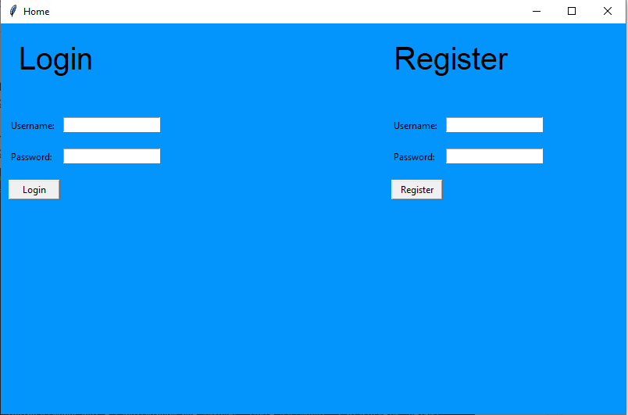
Having created the interface for the user to register or login, I now developed a database which would connect to the program and store user information. When users logged in, the information they entered would have to match the information that was stored in the database when they registered.
To develop my database, I will use SQLite.
Setting up the database took quite long as I had to make sure that the table would receive the information in the correct way. After a few tries, I managed to correctly initialise the database.
After initialising my database, I created a table which will store the username and password of users.
def createTable():
conn = sqlite3.connect('ProjectileMotionGame.db') #connects to database
conn.execute("PRAGMA foreign_keys = 1")
c = conn.cursor() #cursor class allows you to invoke methods that execute sqlite statements
#table is created with username and password fields
c.execute("""CREATE TABLE users(
username text PRIMARY KEY,
password text
)""")
conn.commit() #changes are saved
conn.close() #connection closed

Now, I needed to link the entry boxes to the database so that user information could be stored and queried from it.
For registering:
#procedure to register the user
def registerUser(enteredUsername,enteredPassword): #takes entered values as parameters
conn = sqlite3.connect('ProjectileMotionGame.db') #connects to database
c = conn.cursor() #cursor class allows you to invoke methods that execute sqlite statements
c.execute("INSERT INTO users VALUES (?,?)",(enteredUsername,enteredPassword)) #inserts values into the database
conn.commit() #changes are saved
conn.close() #connection closed

For login:
#procedure to login the user
def loginUser(enteredUsername,enteredPassword): #takes entered values as parameters
conn = sqlite3.connect('ProjectileMotionGame.db') #connects to database
c = conn.cursor() #cursor class allows you to invoke methods that execute sqlite statements
validate = c.execute("SELECT username, password FROM users WHERE username=?", (enteredUsername,)).fetchone() #checks database for entries with the corresponding username
if validate: # if an entry is found
username, password = validate
if enteredPassword == validate[1]: #checks entered password against stored password
window = Toplevel()
label = Label(window,text="Login successful").grid(row=1)
else:
window = Toplevel()
label = Label(window,text="Login unsuccessful").grid(row=1)
else:
window = Toplevel()
label = Label(window,text="Login unsuccessful").grid(row=1)

However, there is currently minimal validation of the user inputs. For example, this means that two users could potentially sign up with the same username.
Therefore, I will now add more validation to the procedure for registering.

Here is the updated procedure:
def registerUser(enteredUsername,enteredPassword): #takes entered values as parameters
conn = sqlite3.connect('ProjectileMotionGame.db') #connects to database
c = conn.cursor() #cursor class allows you to invoke methods that execute sqlite statements
#checks to see if username is already in database
for row in c.execute("SELECT * FROM users WHERE username=?",(enteredUsername,)):
window = Toplevel()
label = Label(window,text="Registration unsuccessful").grid(row=1)

#if the username is not already taken, carry on as normal
else:
c.execute("INSERT INTO users VALUES (?,?)",(enteredUsername,enteredPassword)) #inserts values into the database
window = Toplevel()
label = Label(window,text="Registration successful").grid(row=1)
conn.commit() #changes are saved
conn.close() #connection closed

I have now finished the development of this module. I will now test the module using my test plan. If any errors are found, I will correct them and provide justification for any actions I take.

Milestone 1a: Part 2 – Testing

Test Number | Success Criteria Reference | Description | Input(s) | Expected Output(s)
4 | 6 | User can sign up | Normal: e.g. username = mark; password = Jhnd3728df  Erroneous: e.g. username = mark ; password = “” | Normal: Displays a pop up screen saying that registration is complete.  Erroneous:  Displays a pop up screen saying that the password has not be the specified criteria.
5 | 6 | User can login | Normal: e.g. username = mark; password = Jhnd3728df  Erroneous: e.g. username = mark ; password = aa | Normal: Displays a pop up screen saying that the login details are correct.  Erroneous:  Displays a pop up screen saying that login details are incorrect.

TEST NO 4: CHECK USER CAN SIGN UP
Normal Test: username = mark; password = Jhnd3728df
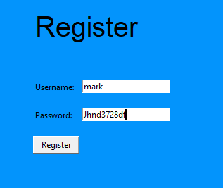
Expected Result: Displays a pop up screen saying that registration is complete.
Actual Result: Pop up screen says “Registration successful”.
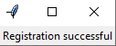
Therefore, this test was successful.

Erroneous Test: username = mark; password = “”
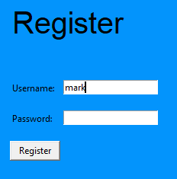
Expected Result: Displays a pop up screen saying that the password has not be the specified criteria.
Actual Result: Pop up screen says “Registration successful”.
Therefore, this test was unsuccessful.
To correct this error, I will need to add extra validation to make sure that all user input for registration must be at least 1 character in length. Otherwise, users will be able to sign up with a blank username and/or password.

TEST NO 5: CHECK USER CAN LOGIN
Normal Test: username = mark; password = Jhnd3728df
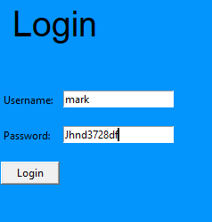
Expected Result: Displays a pop up screen saying that login details are correct.
Actual Result: Pop up screen says “Login successful”.
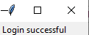
Therefore, this test was successful.

Erroneous Test: username = mark; password = aa
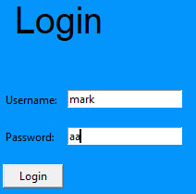
Expected Result: Displays a pop up screen saying that login details are incorrect.
Actual Result: Pop up screen says “Login unsuccessful”.
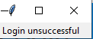
Therefore, this test was successful.

Milestone 1a: Part 3 – Stakeholder feedback

I gave my prototype to my main stakeholder.
He gave the following feedback:
“The password field should be blanked out for privacy reasons.”

Milestone 1a: Part 4 – Review

What has been done?
The Login/Registration module has nearly been completed. The program allows users to login and register with details that they enter. This is done by quering and writing to a connected database with details provided.
How has it been tested?
It has been tested in two ways.
Firstly, I have tested the program against the success criteria generated in the Analysis Section. This was done using normal and erroneous tests to make sure all eventualities were covered.
My stakeholder has also tested the program and provided relevant feedback.
How does it meet the success criteria?
Criteria met:
User can login
Criteria Not met:
User can sign up (Erroneous test was unsuccessful)
What changes need to be made?
- Extra validation to make sure that all user inputs for registration must be at least 1 character in length.
- Password field blanked out so that passwords entered are kept private.
Changes to success criteria / test plan as a result of this milestone
I have added the following success criteria.
Criteria Number | Criteria | How it will be evidenced
11 | User inputs into the password field will be blanked out | Screenshot of the game window + coding + testing

I have added the following test.
Test Number | Success Criteria Reference | Description | Input(s) | Expected Output(s)
11 | 11 | Passwords entered are not visible | Any input | **********

Milestone 1b: Part 1 – Refinement of the Login/ Registration module

In this milestone, I will refine and test the registration part of my program to make sure that blank usernames/ passwords cannot be submitted. I will also make sure that inputs into the password field are blanked out.
This is the updated procedure for registering a user, with the appropriate validation included to make sure that the username/ password fields cannot be left blank. The program checks whether the username and password entered are at least 1 character in length.
This procedure relates to the ‘password validation’ algorithm that I wrote in the design section.
#procedure to register the user

def registerUser(enteredUsername,enteredPassword): #takes entered values as parameters
if len(enteredPassword)>=1 and len(enteredUsername)>=1: #if username/ password field is not blank
conn = sqlite3.connect('ProjectileMotionGame.db') #connects to database
c = conn.cursor() #cursor class allows you to invoke methods that execute sqlite statements
#checks to see if username is already in database
for row in c.execute("SELECT * FROM users WHERE username=?",(enteredUsername,)):
window = Toplevel()
label = Label(window,text="Registration unsuccessful").grid(row=1)

#if the username is not already taken, carry on as normal
else:
c.execute("INSERT INTO users VALUES (?,?)",(enteredUsername,enteredPassword)) #inserts values into the database
window = Toplevel()
label = Label(window,text="Registration successful").grid(row=1)
conn.commit() #changes are saved
conn.close() #connection closed
else: #if username/ password field is blank
window = Toplevel()
label = Label(window,text="Username/ Password cannot be blank").grid(row=1)

These are the updated parts of the the main menu procedure which will make sure that the password entries are blanked out. Instead, the character * will be shown.
#login labels and entries
loginUsernameLabel = Label(window,bg="#0394fc",text="Username: ").place(x=10, y=120)
loginUsernameEntry = Entry(window)
loginUsernameEntry.place(x=80, y=120)
loginPasswordLabel = Label(window,bg="#0394fc",text="Password: ").place(x=10, y=160)
loginPasswordEntry = Entry(window,show="*") #the password is blanked out
loginPasswordEntry.place(x=80, y=160)

#login button
loginButton = Button(window,text="Login",width="8",command=lambda:loginUser(loginUsernameEntry.get(),loginPasswordEntry.get())).place(x=10, y=200)

#register labels and entries
registerUsernameLabel = Label(window,bg="#0394fc",text="Username: ").place(x=500, y=120)
registerUsernameEntry = Entry(window)
registerUsernameEntry.place(x=570, y=120)
registerPasswordLabel = Label(window,bg="#0394fc",text="Password: ").place(x=500, y=160)
registerPasswordEntry = Entry(window,show="*") #the password is blanked out
registerPasswordEntry.place(x=570, y=160)

The refinement of the login/ registration module is now complete.

Milestone 1b: Part 2 – Testing

Test Number | Success Criteria Reference | Description | Input(s) | Expected Output(s)
4 | 6 | User can sign up | Normal: e.g. username = mark; password = Jhnd3728df  Erroneous: e.g. username = mark ; password = “” | Normal: Displays a pop up screen saying that registration is complete.  Erroneous:  Displays a pop up screen saying that the password has not be the specified criteria.
11 | 11 | Passwords entered are not visible | Any input | **********

TEST NO 4: CHECK USER CAN SIGN UP
Normal Test: username = mark; password = Jhnd3728df
Expected Result: Displays a pop up screen saying that registration is complete.
Actual Result: Pop up screen says “Registration successful”.
Therefore, this test was successful.

Erroneous Test: username = mark; password = “”
Expected Result: Displays a pop up screen saying that the password has not be the specified criteria.
Actual Result: Pop up screen says “Username/ Password cannot be blanl”.
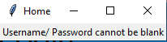
Therefore, this test was successful.

TEST NO 11: CHECK PASSWORDS ENTERED ARE NOT VISIBLE
Test: username = mark; password = Jhnd3728df
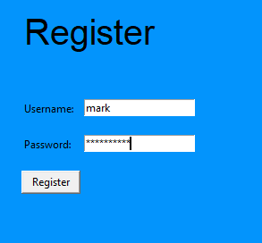
Expected Result: **********
Actual Result: **********
Therefore, this test was successful.

Milestone 1b: Part 3 – Stakeholder feedback

I gave my refined prototype to my main stakeholder.
He gave the following feedback:
“So far everything looks good!”

Milestone 1b: Part 4 – Review

What has been done?
The Login/Registration module has been refined and completed. The program allows users to login and register with details that they enter. This is done by quering and writing to a connected database with details provided.
How has it been tested?
It has been tested in two ways.
Firstly, I have tested the program against the updated success criteria generated in the previous milestone. This was done using normal and erroneous tests to make sure all eventualities were covered.
My stakeholder has also tested the program and provided relevant feedback.
How does it meet the success criteria?
Criteria met:
User can login
User can sign up (Erroneous test was unsuccessful)
Passwords entered are not visible
What changes need to be made?
None.
Changes to success criteria / test plan as a result of this milestone
None.

Milestone 2: Part 1 – Development of the Physics Engine

In this milestone, I will develop and test a physics engine which will be responsible for calculating the paths that projectiles will take.
This function takes in the required values and outputs the change in the projectile position. Coding this function was quite complex and I had to do many dry runs to make sure that the calculations were correct. For example, at one point I accidentally put a plus instead of a minus which meant that all of the projectile calculations were incorrect. Below is the finalised function.
#function for updating the projectile position
def updateProjectile(initVelocity,xProjectile,yProjectile,angle): #takes in required values as parameters
time_now = pygame.time.get_ticks() #uses pygame to find current time
#validates that initial velocity is greater than 0
if initVelocity>0:
time_change = time_now - start_time #calculates change in time between start of the game and now
#horizontal and vertical displacement calculated
xDisplacement = initVelocity*math.cos(angle)*time_change
yDisplacement = initVelocity*math.sin(angle)*time_change - (0.5*gravity*time_change*time_change)
#displacement is added onto the intial position
xProjectile = xProjectile + xDisplacement
yProjectile = yProjectile + yDisplacement
else:
window = Toplevel()
label = Label(window,text="Projectile motion cannot be calculated. Velocity must be greater than 0").grid(row=1)

return(xProjectile,yProjectile)

However, there is currently no way for the user to input values into the system.
As said in my success criteria, the user will use a slider bar system to input these values.
I will now create this slider bar system.
def home():
#window setup
window = Tk()
window.title("Sliders")
window.minsize(800,500)
window.configure(bg="#0394fc")

#label and slider for velocity entry
velocityLabel = Label(window,text="Velocity 0 to 30 (m/s): ")
velocityLabel.place(x=0,y=20)
velocitySlider = Scale(window, from_=0.0, to=30.0, orient=HORIZONTAL,length=300,resolution=0.1)
velocitySlider.place(x=0,y=40)

#label and slider for angle entry
angleLabel = Label(window,text="Angle 0 to 90 (degrees): ")
angleLabel.place(x=400,y=20)
angleSlider = Scale(window, from_=0.0, to=90.0, orient=HORIZONTAL,length=300,resolution=0.1)
angleSlider.place(x=400,y=40)

#button used to submit values to the game
submitButton = Button(window,text="Submit",width="8")
submitButton.place(x=320,y=100)

window.mainloop()

This is how the GUI of the slider bar system looks.
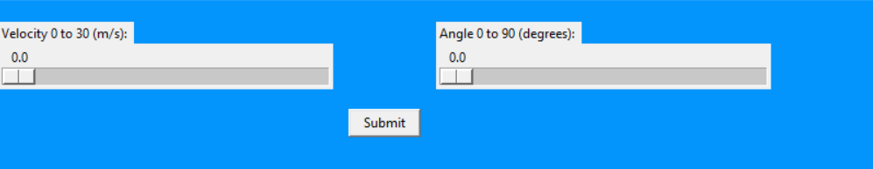
I now need to link the slider bar system with the function for updating the projectile path so that the user input will be used in the game.
def home():
#window setup
window = Tk()
window.title("Sliders")
window.minsize(800,500)
window.configure(bg="#0394fc")

#label and slider for velocity entry
velocityLabel = Label(window,text="Velocity 0 to 30 (m/s): ")
velocityLabel.place(x=0,y=20)
velocitySlider = Scale(window, from_=0.0, to=30.0, orient=HORIZONTAL,length=300,resolution=0.1)
velocitySlider.place(x=0,y=40)

#label and slider for angle entry
angleLabel = Label(window,text="Angle 0 to 90 (degrees): ")
angleLabel.place(x=400,y=20)
angleSlider = Scale(window, from_=0.0, to=90.0, orient=HORIZONTAL,length=300,resolution=0.1)
angleSlider.place(x=400,y=40)

#button used to submit values to the game
submitButton = Button(window,text="Submit",width="8",command=lambda: getval(velocitySlider.get(),angleSlider.get()))
submitButton.place(x=320,y=100)

window.mainloop()

#gets the values from the sliders
def getval(x,y):
updateProjectile(x,0,0,y) #sends the values to the updateProjectile function

The development of the physics engine module is now complete.

Milestone 2: Part 2 – Testing

Test Number | Success Criteria Reference | Description | Input(s) | Expected Output(s)
2 | 4 | Projectile motion is calculated correctly | Normal: e.g. velocity = 25 m/s; angle = 60 degrees, time = 2  Erroneous: e.g. velocity = 0 m/s; angle = 0 degrees | Normal: Displacment-x = 25cos15 * 2 = 25.0; displacement-y = 25sin15* 2 - 0.5 * g * 2 * 2 = 23.69  Erroneous: Error message saying that the projectile motion cannot be calculated.

TEST NO 2: CHECK THAT PROJECTILE MOTION IS CALCULATED CORRECTLY
Normal Test: velocity = 25; angle = 60, time = 2
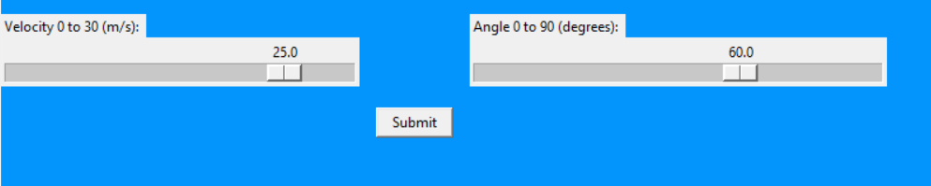
Expected Result: Displacement-x = 25.0 , Displacement-y = 23.69
Actual Result:
Therefore, this test was successful.

Erroneous Test: velocity = 0; angle = 0, time = 2
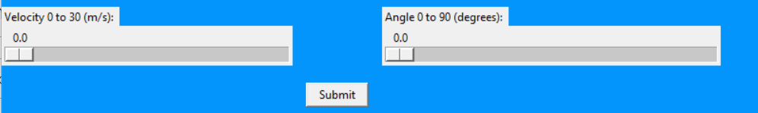
Expected Result: Error message saying that the projectile motion cannot be calculated.
Actual Result:
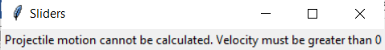
Therefore, this test was successful.

Milestone 2: Part 3 – Stakeholder feedback

I gave the physics engine prototype to my main stakeholder.
He gave the following feedback:
“I would like the background and foreground of the labels to be refined. They should be the same colour.”

Milestone 2: Part 4 – Review

What has been done?
The physics engine module has been completed. The module allows users to enter the speed and angle of projectile flight and calculates the projectile path. This is done through a mathematical algorithm.
How has it been tested?
It has been tested in two ways.
Firstly, I have tested the program against the success criteria generated in the Analysis Section. This was done using normal and erroneous tests to make sure all eventualities were covered.
My stakeholder has also tested the program and provided relevant feedback.
How does it meet the success criteria?
Criteria met:
Projectile motion is calculated.
Criteria Not met:
None.
What changes need to be made?
- Background and the foreground of the labels to be refined to be the same colour.
Changes to success criteria / test plan as a result of this milestone
None

Milestone 3a: Part 1 – Development of Game Animation & Refinement of Physics Engine

In this milestone, I will develop and test the part of my system which will animate the projectile motion across the screen. This will involve relating the mathematical calulcations to pygame animations.
In addition, I will act on my stakeholder feedback from the previous section and ensure that the background and foreground of the labels are refined to be the same colour.
I first developed the pygame animation mainloop which will handle everything that is related to the game animation.
import pygame #imports pygame module
pygame.init() #initialises pygame
screen = pygame.display.set_mode((1000,600)) #sets screen
clock = pygame.time.Clock() #sets clock
running = True
while running: #pygame loop
for event in pygame.event.get():
if event.type == pygame.QUIT:
running = False
pygame.quit()
sys.exit()

At the moment, when the animation is loaded, only a black screen can be seen.
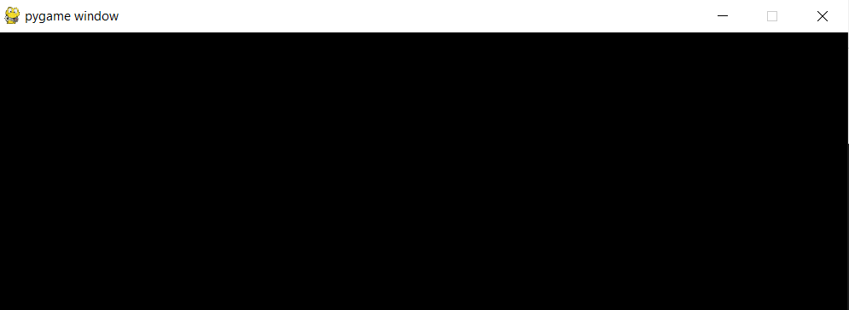
Therefore, I will give the game a blue screen background.

import pygame #imports pygame module
pygame.init() #initialises pygame
screen = pygame.display.set_mode((1000,600)) #sets screen
clock = pygame.time.Clock() #sets clock
running = True
while running: #pygame loop
for event in pygame.event.get():
if event.type == pygame.QUIT:
running = False
pygame.quit()
sys.exit()

screen.fill((52,110,235)) #screen background
pygame.display.flip() #updates display

The blue background can now been seen below.
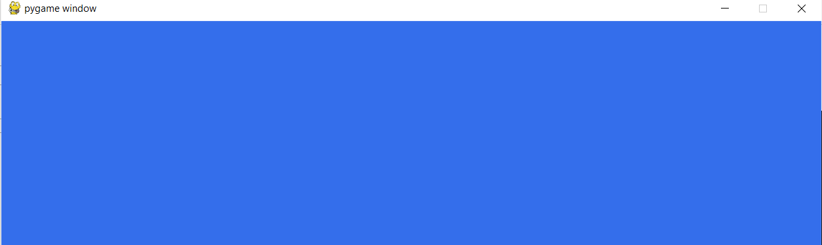
I will next create the target object which the user will be trying to fire the projectile at.
To do this, I will use a library called Pymunk.
#initialises target
def createTarget(space):
body = pymunk.Body(body_type=pymunk.Body.STATIC)
body.position= (900,450) #specifies position
shape = pymunk.Circle(body,50) #shape type
space.add(body,shape)
return shape
#draws target on pygame screen
def drawTarget(target):
xPosition = int(target.body.position.x)
yPosition = int(target.body.position.y)
pygame.draw.circle(screen,(0,0,0),(xPosition,yPosition),50)

Here you can seen the target animated on the screen.
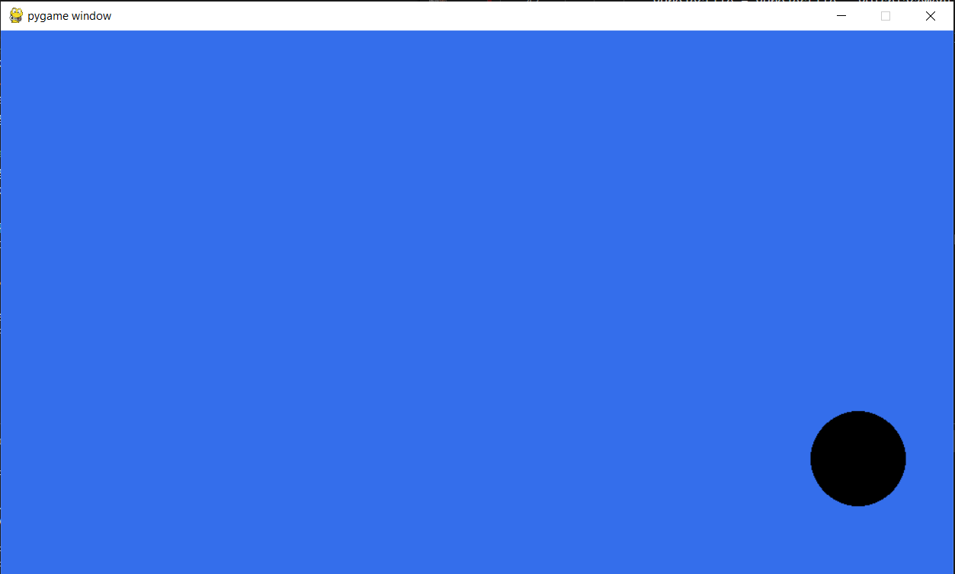
I will now create the projectile object and link it with the physics engine so the projectile is animated on the screen.
To make this pygame animation work, I had to made some changes to the physics engine algorithm.
Firstly, pygame calculates its x-y coordinates from the topleft corner (as shown below). This meant that I had to add subtract the actual y-coordinate from the height of the screen to work out the pygame y-coordinate.
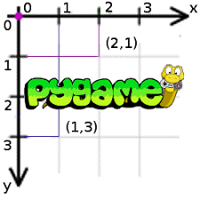
Secondly, I had to scale up my x-y coordinates to the screen size. This is because for most calculations, the x-y displacements would not exceed around 20 metres. However, my screen size was 600 x 600 pixels. Therefore, I scaled up the coordinates by a factor of 10 so that the user could better see how the projectile travelled.
Finally, to ensure that the animation stopped when the projectile left the screen, I implemented boundary conditions meaning that if the x/y coordinate was greater than the screen size, then the game would end. This relates to the ‘on the screen’ algorithm that I wrote in the design section.
This is how my game animation code finally looked.
#pygame mainloop
def pygame(x,y):
import pygame
xProjectile = 0
yProjectile = 0
#initialises target
def createTarget(space):
body = pymunk.Body(body_type=pymunk.Body.STATIC)
body.position= (400,450) #specifies position
shape = pymunk.Circle(body,50) #shape type
space.add(body,shape)
return shape
#draws target on pygame screen
def drawTarget(target):
xPosition = int(target.body.position.x)
yPosition = int(target.body.position.y)
pygame.draw.circle(screen,(0,0,0),(xPosition,yPosition),50)

def updateProjectile(initVelocity,xProjectile,yProjectile,angle): #takes in required values as parameters
timeNow = pygame.time.get_ticks() #uses pygame to find current time
#validates that initial velocity is greater than 0
if initVelocity>0:
timeChange = timeNow - startTime #calculates change in time between start of the game and now
timeChange = timeChange/2000
#horizontal and vertical displacement calculated
xDisplacement = initVelocity*math.cos(math.radians(angle))*timeChange
yDisplacement = ((initVelocity*math.sin(math.radians(angle))*timeChange) - (0.5*(gravity)*timeChange*timeChange))
yAnimate = 10*yDisplacement
xAnimate = 10*xDisplacement
#displacement is added onto the intial position
xProjectile = xProjectile + xAnimate
yProjectileReal = yProjectile + yDisplacement
yProjectile = 600 - (yProjectile + yAnimate) #change for pygame
else:
window = Toplevel()
label = Label(window,text="Projectile motion cannot be calculated. Velocity must be greater than 0").grid(row=1)
#boundary conditions
if xProjectile>600:
running = False
pygame.quit()
sys.exit()
if yProjectileReal>600 or yProjectileReal<0:
running = False
pygame.quit()
sys.exit()

screen.blit(projectileImg,(xProjectile,yProjectile))
pygame.init() #initialises pygame
screen = pygame.display.set_mode((600,600)) #sets screen

space = pymunk.Space()
target1 = createTarget(space)
startTime = pygame.time.get_ticks()
projectileImg = pygame.image.load('projectile1.png')
clock = pygame.time.Clock() #sets clock
running = True
while running: #pygame loop
for event in pygame.event.get():
if event.type == pygame.QUIT:
running = False
pygame.quit()
sys.exit()

screen.fill((52,110,235)) #screen background
#gets the values from the sliders
drawTarget(target1)
updateProjectile(x,xProjectile,yProjectile,y) #sends the values to the updateProjectile function
pygame.display.flip() #updates display
clock.tick_busy_loop(FPS)

This is how the game screen looks when the projectile is in motion and is heading towards the target.
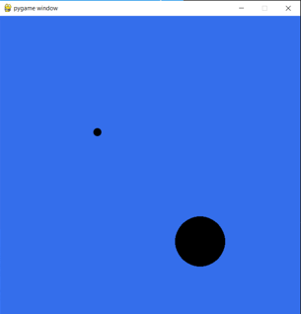
In addition to creating the game animation, I acted on my stakeholder feedback from the previous section to ensure that the background and foreground of the labels were refined to be the same colour.
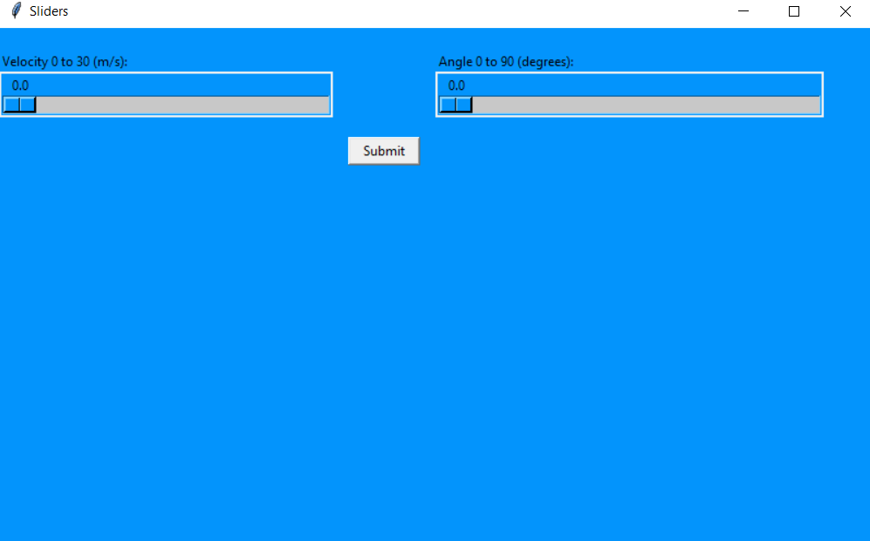
I have now finished the development of this module. I will now test the module using my test plan. If any errors are found, I will correct them and provide justification for any actions I take.

Milestone 3a: Part 2 – Testing

Test Number | Success Criteria Reference | Description | Input(s) | Expected Output(s)
1 | 4 | User can fire the projectile using the slider bar system | Normal: e.g. velocity = 25 m/s; angle = 60 degrees  Erroneous: e.g. velocity = 0 m/s; angle = 0 degrees | Normal: Projectile is animated to move across the game screen with given velocity at at specified angle of release.  Erroneous: Displays a pop up screen saying that invalid parameter for speed has been entered.
8 | 1 | Game is windowed | N/A | Window containing the game

TEST NO 1: CHECK USER CAN FIRE THE PROJECTILE USING THE SLIDER BAR SYSTEM
Normal Test: velocity = 25; angle = 60
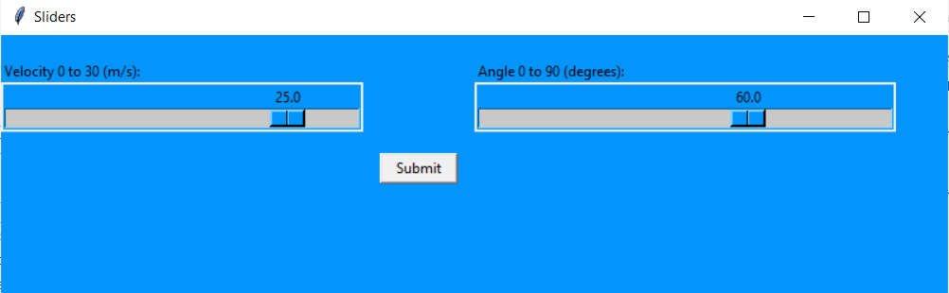
Expected Result: Projectile is animated to move across the game screen with given velocity at at specified angle of release.

Actual Result:
Here you can see 3 snapshots of the projectile moving across the game screen
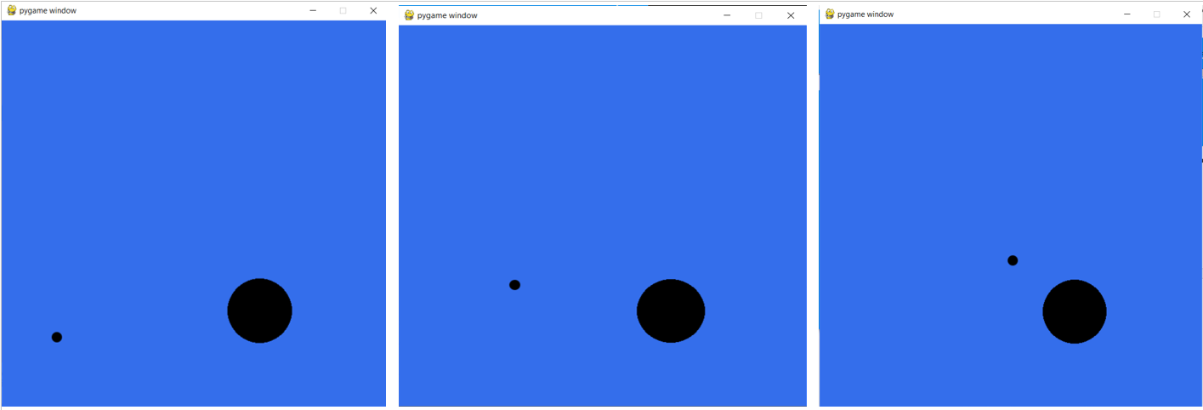
Therefore, this test was successful.

Erroneous Test: velocity = 0; angle = 0
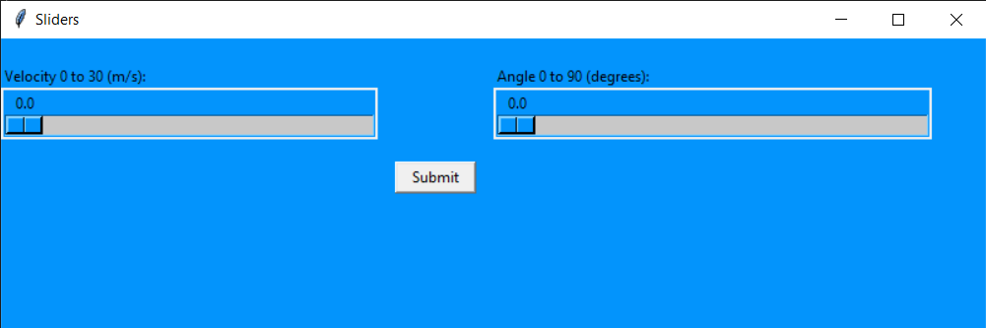
Expected Result: Displays a pop up screen saying that invalid parameter for speed has been entered.
Actual Result:
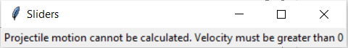
Therefore, this test was successful.

TEST NO 8: CHECK GAME IS WINDOWED
Test:
Expected Result: Window containing the game
Actual Result:
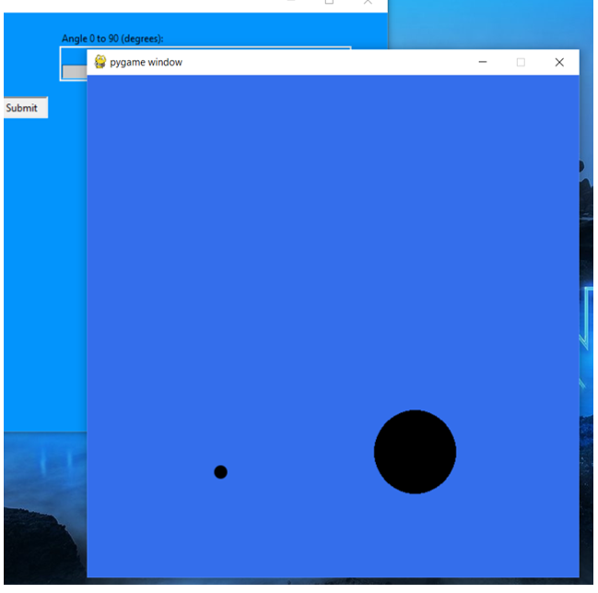
Therefore, this test was successful.

Milestone 3a: Part 3 – Stakeholder feedback

I gave my prototype to my main stakeholder.
He gave the following feedback:
“Customisability is key. Maybe make a shop where the user can buy skins using ingame currency earned from reaching the target, and they can select a skin from their purchased items. (If you can add different masses and densities to the skins that'd be cool). This way the user has something to work towards.”

Milestone 3a: Part 4 – Review

What has been done?
The development of the game animation engine has nearly been completed & the refinement of the physics engine has been completed. The program allows users to choose the velocity and angle of release of the projectile and it is animated on the game screen.
How has it been tested?
It has been tested in two ways.
Firstly, I have tested the program against the success criteria generated in the Analysis Section. This was done using normal and erroneous tests to make sure all eventualities were covered.
My stakeholder has also tested the program and provided relevant feedback.
How does it meet the success criteria?
Criteria met:
User can fire the projectile using the slider bar system
Game is windowed
Criteria Not met:
None
What changes need to be made?
As a result of stakeholder feedback, I will make the following changes.
- Allow customability of projectile skins linked to user performance
Changes to success criteria / test plan as a result of this milestone
I have added the following success criteria.
Criteria Number | Criteria | How it will be evidenced
12 | User can change projectile skins. | Screenshot of the game window + coding + testing

I have added the following test.
Test Number | Success Criteria Reference | Description | Input(s) | Expected Output(s)
12 | 12 | User can change projectile skins. | Press button to change skin | Skin is changed and new skin can be seen during game animation

Milestone 3b: Part 1 – Refinement of Game Animation

In this milestone, I will refine and test the game animation part of my program to make sure that users can customise projectile skins.
I first added a dropdown menu to allow users to choose their option of projectile skins.
#skins options
skinOptions = ['Dot','Fukiya','Rocket'] #the options available
skinVariable = StringVar(window) #variable that holds the value
skinVariable.set(skinOptions[0])
skinLabel = Label(window,text="Choose projectile skin: ",bg="#0394fc")
skinLabel.place(x=0,y=180)
chooseSkin = OptionMenu(window,skinVariable,*skinOptions) #dropdown menu
chooseSkin.place(x=0,y=200)

This is how the GUI now looks with the dropdown menu incorporated with the slider bar system.
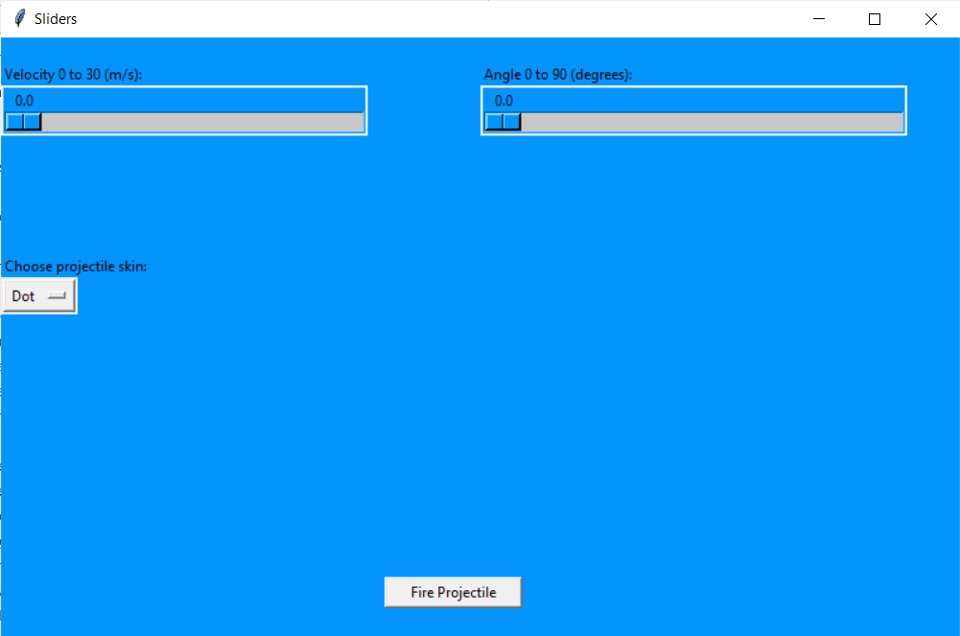
The option that the user chooses is passed into the game alongside the velocity and angle of release.
#button used to submit values to the game
submitButton = Button(window,text="Fire Projectile",width="15",command=lambda: pygame(velocitySlider.get(),angleSlider.get(),skinVariable.get()))
submitButton.place(x=320,y=450)

This algorithm selects the correct projectile skin based on the user’s option.
if z == 'Fukiya':
projectileImg = pygame.image.load(“fukiya.png')
elif z== 'Rocket':
projectileImg = pygame.image.load(“rocket.png')
else:
projectileImg = pygame.image.load(' projectile1.png')

The refinement of the game animation is now complete.

Milestone 3b: Part 2 – Testing

Test Number | Success Criteria Reference | Description | Input(s) | Expected Output(s)
12 | 12 | User can change projectile skins. | Press button to change skin | Skin is changed and new skin can be seen during game animation

TEST NO 12: CHECK GAME IS WINDOWED
Test: press button to change skin
Expected Result: Skin is changed
Actual Result:
I chose a Fukiya projectile.
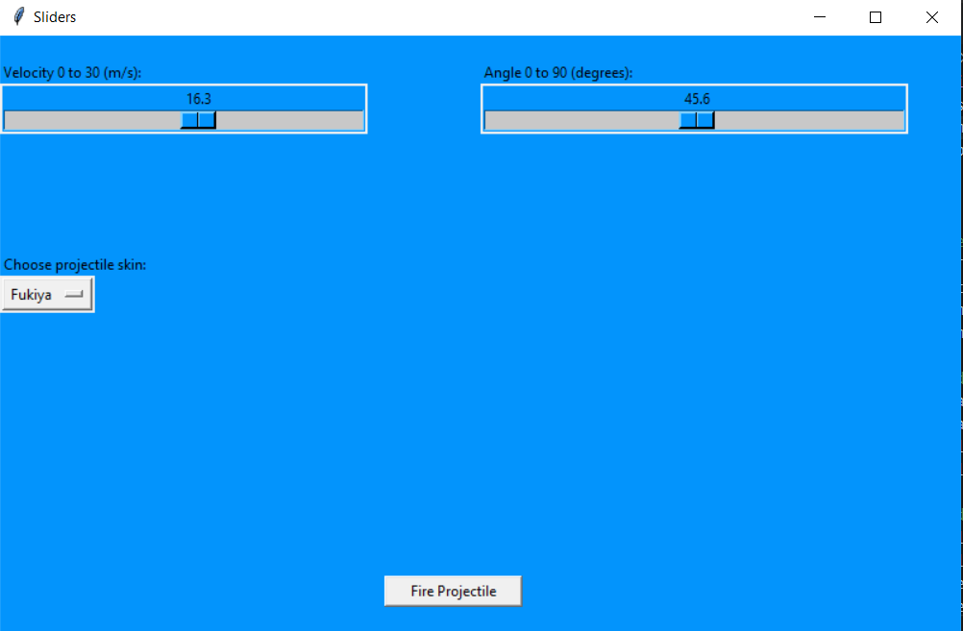

A fukiya projectile was animated on the game screen.
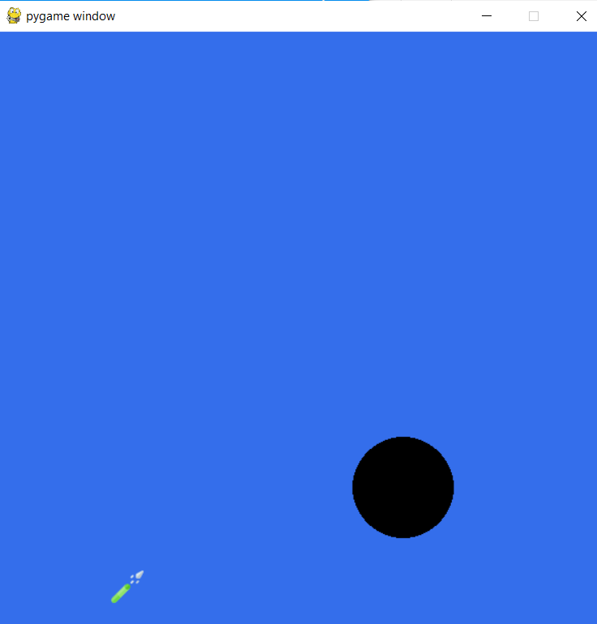
Therefore, this test was successful.

Milestone 3b: Part 3 – Stakeholder feedback

I gave my refined prototype to my main stakeholder.
He gave the following feedback:
“This certainly adds extra customisability to the game.”

Milestone 3b: Part 4 – Review

What has been done?
The game animation module has been refined and completed. The program allows users to choose the velocity, angle of release and skin of the projectile and it is animated on the game screen.
How has it been tested?
It has been tested in two ways.
Firstly, I have tested the program against the updated success criteria generated in the previous milestone.
My stakeholder has also tested the program and provided relevant feedback.
How does it meet the success criteria?
Criteria met:
User can change projectile skins.
What changes need to be made?
None.
Changes to success criteria / test plan as a result of this milestone
None.

Milestone 4: Part 1 – Development of Collision Detection

In this milestone, I will develop and test the part of my system which will detect whether the projectile and target have collided.
This function relates to the ‘projectile vs target’ algorithm that I wrote in the design section.
I first developed a function which takes in the values of the projectile displacement and calculates the distance between the projectile and target by using Pythagoras theorem.
def collisionCheck(xProjectile,yProjectile): #takes in current projectile values
distance = math.sqrt(math.pow(400-xProjectile,2) + math.pow(450-yProjectile,2)) #calculates distance using pythagoras theorem

However, I realised that the objects themselves take up space meaning that it is unlikely that the distance between the objects will be exactly zero.
Therefore, I added some leeway distance between the objects where a collision would still be detected.
After discussions with my stakeholder, we decided that the leeway would be 70m to give the user a good chance of hitting the target.
def collisionCheck(xProjectile,yProjectile): #takes in current projectile values
distance = math.sqrt(math.pow(400-xProjectile,2) + math.pow(450-yProjectile,2)) #calculates distance using pythagoras theorem
if distance<70: #gives leeway as object sizes mean that the distance may never actually be zero
pygame.quit()

Once the objects has collided, the game ends and the user is informed via a pop up window.
def collisionCheck(xProjectile,yProjectile): #takes in current projectile values
def collidePopup():
window = Toplevel()
label = Label(window,text="Collision. You have completed the level").grid(row=1) #displays pop up screen telling user there has been a collision

distance = math.sqrt(math.pow(400-xProjectile,2) + math.pow(450-yProjectile,2)) #calculates distance using pythagoras theorem
if distance<70: #gives leeway as object sizes mean that the distance may never actually be zero
pygame.quit()
collidePopup() #calls collision function

The development of the collision detection is now complete.

Milestone 4: Part 2 – Testing

Test Number | Success Criteria Reference | Description | Input(s) | Expected Output(s)
10 | 10 | Collisions are detected between the projectile and target | Projectile velocity & angle; Target position | User is told that they have hit the target and completed the level.

TEST NO 10: CHECK COLLISIONS ARE DETECTED BETWEEN THE PROJECTILE AND TARGET
Test: velocity = 25; angle = 60; target position = 400,450
Expected Result: User is told that they have hit the target and completed the level.
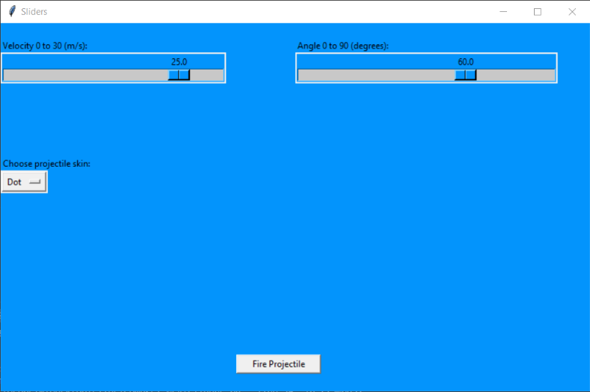
Actual Result:

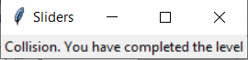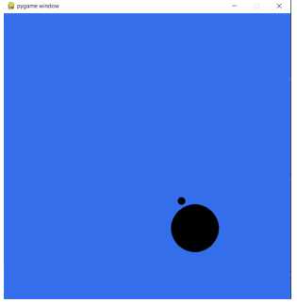
Therefore, this test was successful.

Milestone 4: Part 3 – Stakeholder feedback

I gave my prototype to my main stakeholder.
He gave the following feedback:
“It is very good that there is now collision detection. This effectively ties the game together”.

Milestone 4: Part 4 – Review

What has been done?
The collision detection module has been completed. The program calculates whether there has been a collision and if so, informs the user and ends the game.
How has it been tested?
It has been tested in two ways.
Firstly, I have tested the program against the success criteria generated in the Analysis Section.
My stakeholder has also tested the program and provided relevant feedback.
How does it meet the success criteria?
Criteria met:
Collisions are detected between the projectile and target
What changes need to be made?
None.
Changes to success criteria / test plan as a result of this milestone
None.

Milestone 5: Part 1 – Development of saving user progress

In this milestone, I will develop and test the part of my system which will allow users’ progress to be saved. This will involve making my database relational. To do this, I will add another table which will use ‘username’ as a foreign key so that the login/registration table and the user progress table are linked. This information will then be passed to the game when the user is logged in so that the correct level can be loaded.
I first created the new table in the database and linked the ‘username’ primary key as a foreign key so that the tables are connected.
Getting the foreign keys to work correctly took some time and I had to recreate some tables in order to do so.
I set the default level in the database to 1 as all first time users would obviously be starting from the lowest level so this information should be added to the database as soon as they are registered.
def createTable():
conn = sqlite3.connect('ProjectileMotionGame.db') #connects to database
conn.execute("PRAGMA foreign_keys = 1")
c = conn.cursor() #cursor class allows you to invoke methods that execute sqlite statements
c.execute("""CREATE TABLE levels(
username text,
level int DEFAULT 1,
FOREIGN KEY (username) REFERENCES users(username))""") #foreign key is defined
conn.commit() #changes are saved
conn.close() #connection closed

Then, there had to be some way of the program knowing what level was stored in the database.
Therefore, I created a function which queries the database for the correct level.
def launch(enteredUsername):
conn = sqlite3.connect('ProjectileMotionGame.db') #connects to database
c = conn.cursor() #cursor class allows you to invoke methods that execute sqlite statements
validate = c.execute("SELECT level FROM levels WHERE username=?", (enteredUsername,)).fetchone() #checks database for entries with the corresponding username

Depending on the data stored in the database, the correct level is loaded.
def launch(enteredUsername):
conn = sqlite3.connect('ProjectileMotionGame.db') #connects to database
c = conn.cursor() #cursor class allows you to invoke methods that execute sqlite statements
validate = c.execute("SELECT level FROM levels WHERE username=?", (enteredUsername,)).fetchone() #checks database for entries with the corresponding username
if validate == '1':
import level1 #loads correct level
elif validate == '2':
import level2

The development of this milestone is now complete.

Milestone 5: Part 2 – Testing

Test Number | Success Criteria Reference | Description | Input(s) | Expected Output(s)
3 | 5 | User’s progress is saved by the game | N/A | When user loads up the game after closing it, they are taken to the right game level.

TEST NO 3: CHECK USER PROGRESS IS SAVED BY THE GAME
Test: newly registered user
Expected Result: User is taken to level 1 of the game
Actual Result:
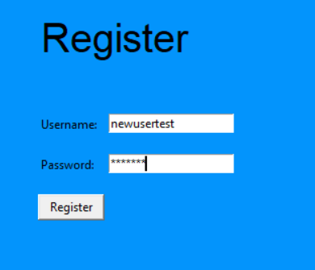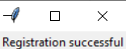
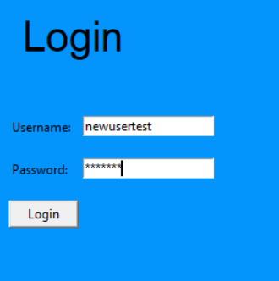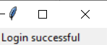
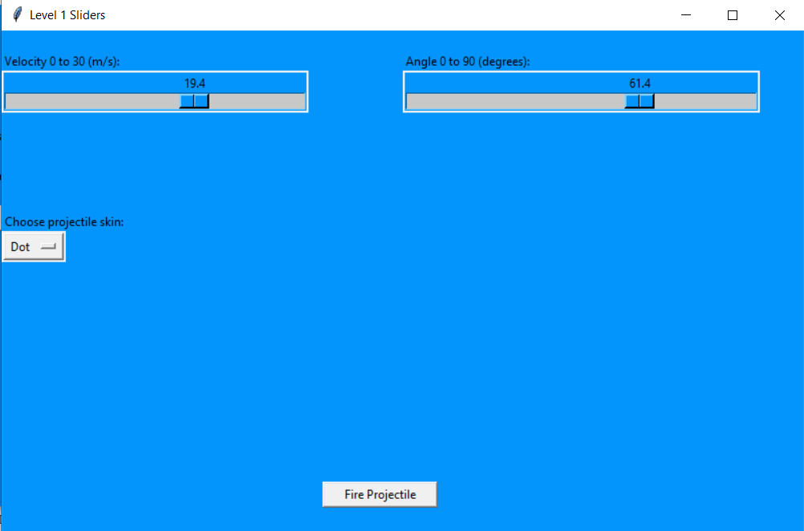
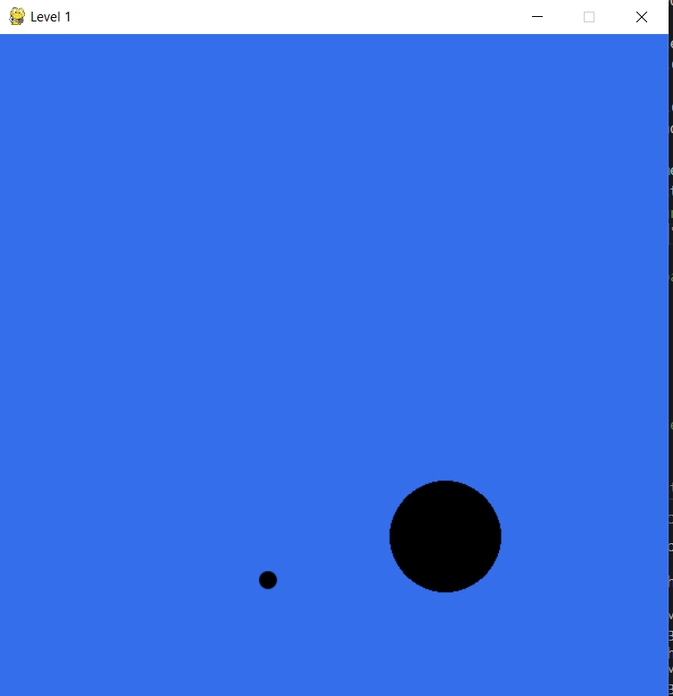
A new user has been created. This account is then logged in to. The game correctly loads the sliders for level 1 and the game animation for level 1 is also correctly loaded.
Therefore, this test was successful.

Milestone 5: Part 3 – Stakeholder feedback

I gave my prototype to my main stakeholder.
He gave the following feedback:
“Saving user progress is crucial to any good game so this development is welcome. There are only a few more success criteria to complete so the development should be finished very soon.”

Milestone 5: Part 4 – Review

What has been done?
User’s progress is now saved by the program. This means that users will be able to unlock new levels as they progress through the game.
How has it been tested?
It has been tested in two ways.
Firstly, I have tested the program against the success criteria generated in the Analysis Section.
My stakeholder has also tested the program and provided relevant feedback.
How does it meet the success criteria?
Criteria met:
User’s progress is saved by the game
What changes need to be made?
None.
Changes to success criteria / test plan as a result of this milestone
None.

Milestone 6: Part 1 – Development of settings, music & instructions

In this milestone, I will finalise the development of my program through creating a settings menu, adding an option for playing music and adding user instructions.
First, I set up the button that will be used to bring up the settings menu.
#settings button
settingsPhoto = PhotoImage(file='settings.png') #references settings image
settingsButton = Button(window,text="Settings",image=settingsPhoto,compound=LEFT).place(x=50,y=430)

This is how the home page looks with the settings button added.
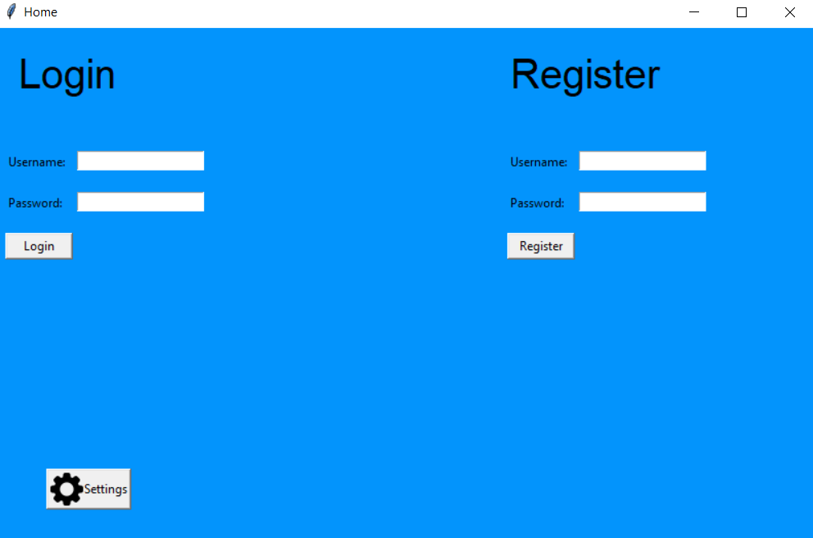
At the moment, the settings menu will contain the options to to turn on music.
So first, I connect the settings button to the settings menu.
settingsButton = Button(window,text="Settings",image=settingsPhoto,compound=LEFT,command=settingsMenu).place(x=50,y=430)

In the settings menu, I create a button that will toggle the music between on and off.
To play the music, I use a module named ‘Winsound’ which allows WAV files to be played.
I create a variable called ‘musicIsOn’ which tracks whether the sound is currently on or off and therefore performs the correct action.
The finished code for this is below.
def settingsMenu():
musicIsOn = False #sets value
def switch(musicIsOn):
if musicIsOn:
musicIsOn = False
winsound.PlaySound(None, winsound.SND_PURGE) #stops music
else:
winsound.PlaySound(r'music.wav',winsound.SND_ASYNC) #plays music
return (musicIsOn == True)

#menu setup

window = Toplevel()
window.title("Settings")
window.minsize(400,250)
window.configure(bg="#0394fc")
#label and button
musicLabel = Label(window,text="Music is Off",bg="#0394fc").place(x=50,y=50)
musicButton = Button(window,text="Toggle Music",command=lambda: switch(musicIsOn)).place(x=250,y=50)

The final part of development is to add the user instructions.
The user instructions will come will the program in the form of a README file.
This file will details frequently asked questions, as well as informing the user of where they can get more help with the game if they require.
To implement this, I created a button labelled instructions, which when clicked on would open the readme file.
#instructions button
instructionsButton = Button(window,text="Instructions",height=2,command=openInstructions).place(x=350,y=430)
window.mainloop()
def openInstructions():
os.startfile('README.txt') #opens the README file

The development of the program is now complete.

Milestone 6: Part 2 – Testing

Test Number | Success Criteria Reference | Description | Input(s) | Expected Output(s)
6 | 8 | Settings button loads the correct screen | Press settings button | Settings screen is shown.
7 | 8 | User can toggle music | Press music button | Music is turned on/ off accordingly
9 | 2 | Users instructions provided | Press instructions button | Instructions given if users requests

TEST NO 6: CHECK SETTINGS BUTTON LOADS THE CORRECT SCREEN
Test: Press settings button
Expected Result: Settings screen is shown
Actual Result:
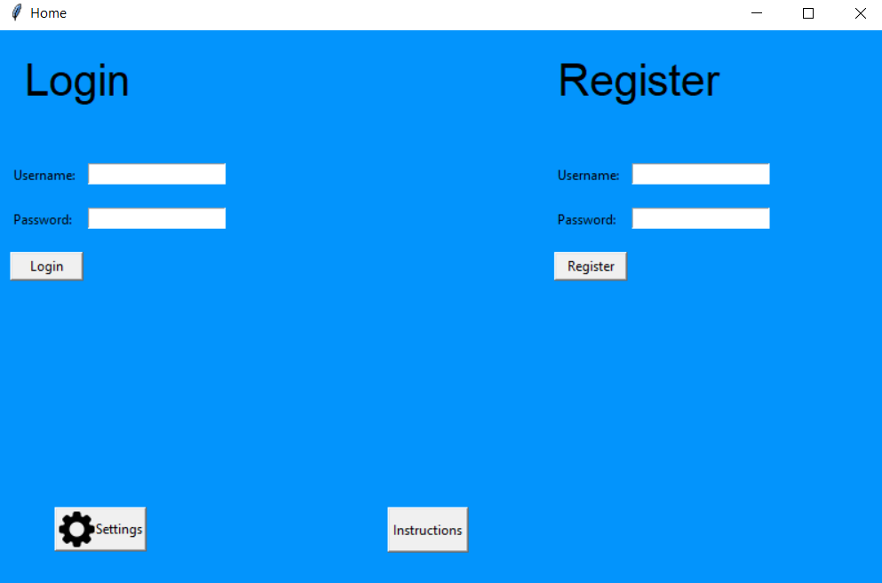
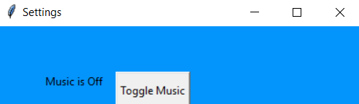

A settings menu is loaded when the settings button is pressed.
Therefore, this test was successful.

TEST NO 8: CHECK USER CAN TOGGLE MUSIC
Test: Press music button
Expected Result: Music is turned on/ off accordingly
Actual Result:
I can’t insert the evidence of the music playing inside this document.
But, I can confirm that the music does turn on and off when pressed.
My stakeholder will also be able to confirm this when he tests the program.

Therefore, this test was successful.
TEST NO 9: CHECK USER INSTRUCTIONS ARE PROVIDED
Test: Press instructions button
Expected Result: Instructions given if users requests
Actual Result:
The README file is loaded when the instructions button is pressed.
Therefore, this test was successful.

Milestone 6: Part 3 – Stakeholder feedback

I gave my prototype to my main stakeholder.
He gave the following feedback:
“The development of the program is now complete. I am happy with the product that has been made so far.”

Milestone 6: Part 4 – Review

What has been done?
A settings menu has been created which contains an option for playing music. User instructions have also been added.
How has it been tested?
It has been tested in two ways.
Firstly, I have tested the program against the success criteria generated in the Analysis Section.
My stakeholder has also tested the program and provided relevant feedback.
How does it meet the success criteria?
Criteria met:
Settings button loads the correct screen
User can toggle music
Users instructions provided
What changes need to be made?
None.
Changes to success criteria / test plan as a result of this milestone
None.

3.4 Evaluation

3.4.1 Testing to inform evaluation

In the post development testing I will use: integration testing, alpha testing and beta testing to ensure that the complete solution is tested for function, robustness and usability.
To do this, I will use the same test criteria as used for the itertative development testing.
I will create a video where the testing is perfomed.
The table below has a timestamp which refers to the time in the video when the test was performed.

Test Number | Success Criteria Reference | Description | Input(s) | Expected Output(s) | Timestamp | Pass/Fail
1 | 3 | User can fire the projectile using the slider bar system | Normal: e.g. velocity = 25 m/s; angle = 60 degrees  Erroneous: e.g. velocity = 0 m/s; angle = 0 degrees | Normal: Projectile is animated to move across the game screen with given velocity at at specified angle of release.  Erroneous: Displays a pop up screen saying that invalid parameter for speed has been entered. | 4.30 | Pass
2 | 4 | Projectile motion is calculated correctly | Normal: e.g. velocity = 25 m/s; angle = 60 degrees, time = 2  Erroneous: e.g. velocity = 0 m/s; angle = 0 degrees | Normal: Displacment-x = 25cos15 * 2 = 25.0; displacement-y = 25sin15* 2 - 0.5 * g * 2 * 2 = 23.69  Erroneous: Error message saying that the projectile motion cannot be calculated. | 4.30 | Pass
3 | 5 | User’s progress is saved by the game | N/A | When user loads up the game after closing it, they are taken to the right game level. | 3.10 | Pass
4 | 6 | User can sign up | Normal: e.g. username = mark; password = Jhnd3728df  Erroneous: e.g. username = mark ; password = “” | Normal: Displays a pop up screen saying that registration is complete.  Erroneous:  Displays a pop up screen saying that the password has not be the specified criteria. | 1.10 | Pass
5 | 6 | User can login | Normal: e.g. username = mark; password = Jhnd3728df  Erroneous: e.g. username = mark ; password = aa | Normal: Displays a pop up screen saying that the login details are correct.  Erroneous:  Displays a pop up screen saying that login details are incorrect. | 2.50 | Pass
6 | 8 | Settings button loads the correct screen | Press settings button | Settings screen is shown. |  | Pass
7 | 8 | User can toggle music | Press music button | Music is turned on/ off accordingly |  | Pass
8 | 1 | Game is windowed | N/A | Window containing the game | 4.30 | Pass
9 | 2 | Users instructions provided | Press instructions button | Instructions given if users requests |  | Pass
10 | 10 | Collisions are detected between the projectile and target | Projectile velocity & angle; Target position | User is told that they have hit the target and completed the level. | 4.40 | Pass
11 | 11 | Passwords entered are not visible | Any input | ********** | 1.20 | Pass
12 | 12 | User can change projectile skins. | Press button to change skin | Skin is changed and new skin can be seen during game animation | 6.05 | Pass

In my video, I also tested for robustness. Below is a list of the features for which robustness was tested alongside a timestamp of when this occurred.
Feature | Timestamp

3.4.2 Success of the solution

In this section, I will use evidence from iterative development testing and post development testing to evaluate my final product against the success criteria generated in the Analysis section.
The success criteria is shown below. It includes two additional criteria that were added during the Development section.
Criteria Number | Criteria
1 | The game will be windowed
2 | User instructions will be provided
3 | The game design will be lightweight
4 | Use of slider bar system to fire projectile
5 | Progress of user in the game is saved
6 | A login/ registration system for users
7 | User details will be stored in a database
8 | Settings menu with option to toggle music
9 | Each game level will be unique e.g. have different values of gravity
10 | There is collision detection between the projectile and target
11 | User inputs into the password field will be blanked out
12 | User can change projectile skins.

I will now go through each of the criteria individually and discuss whether each criteria was fully met, partially met or not met.
Criteria 1: The game will be windowed
This criteria was fully met. This was evidenced in the testing of Milestone 3a and during the post development testing video.
Criteria 2: User instructions will be provided
This criteria was fully met. This was evidenced in the testing of Milestone 6 and during the post development testing video.
Criteria 3: The game design will be lightweight
This criteria was fully met. This was evidenced in the usability testing and during the post development testing video.

Criteria 4: Use of slider bar system to fire projectile
This criteria was fully met. This was evidenced in the testing of Milestone 3a and during the post development testing video.
Criteria 5: Progress of user in the game is saved
This criteria was fully met. This was evidenced in the testing of Milestone 5.
Criteria 6: A login/ registration system for users
This criteria was fully met. This was evidenced in the testing of Milestone 3a and during the post development testing video.
Criteria 7: User details will be stored in a database
This criteria was fully met. This was evidenced in the testing of Milestone 3a and during the post development testing video.
Criteria 8: Settings menu with option to toggle music
This criteria was fully met. This was evidenced in the testing of Milestone 3a and during the post development testing video.
Criteria 9: Each game level will be unique e.g. have different values of gravity
This criteria was fully met. This was evidenced in the testing of Milestone 3a and during the post development testing video.
Criteria 10: There is collision detection between the projectile and target
This criteria was fully met. This was evidenced in the testing of Milestone 3a and during the post development testing video.
Criteria 11: User inputs into the password field will be blanked out
This criteria was fully met. This was evidenced in the testing of Milestone 3a and during the post development testing video.
Criteria 12: User can change projectile skins.
This criteria was fully met. This was evidenced in the testing of Milestone 3a and during the post development testing video.

3.4.3 Describe the final product

3.4.4 Maintenance and Development

